May 2025

|  |
| --- |
| **UN SDGs and AI**  Part 1 – Push of the past and pull of the future  by Debashish Dey, FIA C. Act. |
|  |

Abstract

Adopted in 2015, the United Nations’ Sustainability Development Goals (UN SDGs) form a voluntary framework for countries across the world to address shortcomings for a range of challenges including no poverty, gender inequality and climate action by 2030. As at 2024, we are unlikely to meet these targets and global progress stands at 17% overall. Potential alternative targets and deadlines will need to be set as we approach closer to 2030, and a potential move from voluntary to mandatory enforcement, if we are indeed intent on addressing these shortcomings by 2030.

In this paper, we introduce the core of our challenge – the UN SDGs, discuss progress to date, underlying challenges in progress and what the future holds.

Key words

* Sustainability
* UN SDGs

Disclaimers

Please note the following:

##### Information within this paper is **valid** **up to 31 January 2025**. Hence, there may be updates beyond this date which are not reflected in this paper e.g. changes to any legislation mentioned or updates to any open-source libraries used.

##### This paper is not intended to be a comprehensive audit of models, legislation or underlying viewpoints and challenges associated with UN SDGs. Neither is this paper recommending or promoting one approach over another, nor promoting any of the sources or references stated in this paper. Any user of this paper should still reference the underlying legislation, as well as any standard mentioned in this paper. Should there be any conflict, the underlying information in the relevant standard, reference or legislation supersedes any information presented in this paper.

Though the work in this paper does not fall under the Financial Reporting Council’s Technical Actuarial Standards, this paper has been reviewed XX.

The views expressed in this publication are those of invited contributor(s) and not necessarily those of the Institute and Faculty of Actuaries (IFoA). This paper expresses the views of the individual author(s) and not necessarily those of their employer(s).

The Institute and Faculty of Actuaries does not endorse any of the views stated, nor any claims or representations made in this publication and accept no responsibility or liability to any person for loss or damage suffered as a consequence of their placing reliance upon any view, claim or representation made in this publication. The information and expressions of opinion contained in this publication are not intended to be a comprehensive study, nor to provide actuarial advice or advice of any nature and should not be treated as a substitute for specific advice concerning individual situations. On no account may any part of this publication be reproduced without the written permission of the Institute and Faculty of Actuaries and the invited contributor(s).

Table of Contents

Section 1: Introduction 5

Section 2: Overview of UN SDGs 6

Section 3: Progress update of SDGs 14

Section 4: Addressing the lack of progress 19

Section 5: Wider considerations 26

Section 6: Different roles and actors 36

Section 7: Looking ahead 43

References 46

Appendix 1: Acknowledgements 47

Appendix 2: Useful links 48

Appendix 3: Alternative index measures 49

Appendix 4: Alternative charts of global UN SDG progress 51

Appendix 5: United Nations Framework 57

# Introduction

This is part 1 of a 3-part series of papers where we look to explore the intersection of the United Nations Sustainability Development Goals (UN SDGs) and Artificial Intelligence (AI) over the course of this series.

The aim of this paper is to set the scene and introduce the UN SDGs, progress to date and underlying challenges facing progress. The second paper in the series will give an overview of progress to date of AI, whilst the final third paper will look at the intersection of the UN SDGs and AI, focussing on specific use

In particular, this paper is structured into the following sections:

* **Section 2: Overview of UN SDGs**

This section gives general background to the UN SDGs, introduces key concepts such as the nexus idea, UN universal values, discussion on a few UN-led initiatives which have been used to accelerate the progress and alternative views to the UN SDG paradigm.

* **Section 3: Progress update of SDGs**

This section covers progress to date and expected progress by 2030.

* **Section 4: Addressing the lack of progress**

This section explores potential reasons for the lack of progress to date, the impact of COVID-19 and potential cost to address the UN SDGs.

* **Section 5: Wider considerations**

This section considers moving away from traditional GDP measures and explores the concept of spill overs.

* **Section 6: Different roles and actors**

This section explores the roles of the government, businesses, society and the individual. Further, it explores the potential role of certain industries in particular insurers in addressing the UN SDGs.

* **Section 7: Looking ahead**

In this section we look at the future direction of travel for UN SDGs and proposes recommendations to address UN SDG progress.

# Overview of UN SDGs

## Background

A global United Nations (UN) summit on sustainable development was held in New York, USA over 25th to 27th September 2015, where more than 150 world leaders formally agreeing to the new agenda for global sustainable development (UN, 2015). The 2015 formal resolution introduced a commitment to a new plan, with 169 individual targets grouped into overall 17 sustainable development goals (SDGs). For more details of the official resolution adopted by the UN General Assembly on   
25 September 2015 (*Transforming our world: the 2030 Agenda for Sustainable Development*), please see <https://documents.un.org/doc/undoc/gen/n15/291/89/pdf/n1529189.pdf>. The Resolution is centred around the key themes of people, planet, prosperity, peace and partnership, with an overall *pledge that no one will be left behind*. (Source: <https://documents.un.org/doc/undoc/gen/n15/291/89/pdf/n1529189.pdf>) For current news and background to the UN SDGs, please see <https://www.un.org/sustainabledevelopment/development-agenda/>.

The aim of these development goals is *to find new ways to improve the lives of the world's people, to eradicate poverty, to promote prosperity and well-being for all, to protect the environment, and to fight against climate change* by 2030 (UN, 2015).

The UN SDGs build on years of prior work and initiatives of similar ideas including:

* The UN Brundtland Commission’s publication in 1987 entitled *Our Common Future*, commonly known as the Brundtland Report. The report popularised the term sustainable development, defining the idea of sustainability as *meeting the needs of the present without compromising the ability of future generations to meet their own needs*. (UN, no date (a))
* Agenda 21, adopted by more than 178 countries in 1992 at the Earth Summit held in Rio de Janeiro, Brazil. (UN, no date (b)) It is a non-binding agreement, covering four main areas: i. social and economic; ii. conservation and management of resources; iii. strengthening of major groups e.g. children and women; and iv. means of implementation.
* Millennium Development Goals established in 2000 at the Millennium Summit held on   
  6th to 8th September 2000 in New York, USA, with a target data of 2015. These goals covered 8 areas including reducing extreme poverty and improving environmental sustainability. Please see here for a copy of the task force report published in 2015: <https://www.un.org/millenniumgoals/pdf/MDG_Gap_2015_E_web.pdf>.

For further details of the prior initiatives and adoptions, please see further under the history section at <https://sdgs.un.org/goals>.

## Areas of UN SDGs

As mentioned, there are 169 targets grouped into 17 SDGs. The UN SDGs are detailed further in Figure 2 and Table 1.

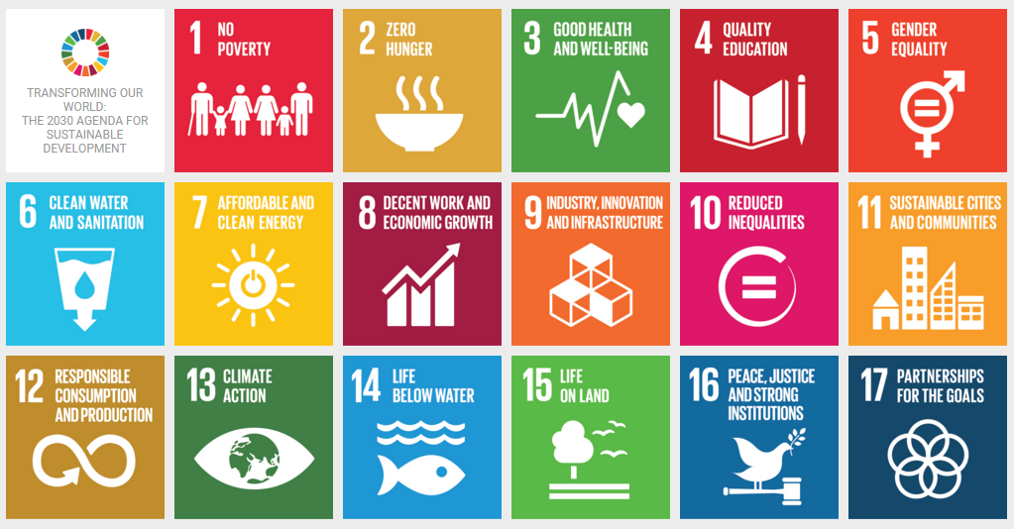

Figure 2: UN Sustainability Goals. (Source: <https://iucn.org/our-work/informing-policy/international-policy/un-sustainable-development-goals>)

There are similar local and regional initiatives around the world including Africa Agenda 2063. Africa Agenda 2063 is a pan-African initiative to promote development and growth across Africa. For further details, please see here: <https://au.int/agenda2063/overview>. To see how this agenda relates to the UN SDGs, please see here: <https://au.int/en/agenda2063/sdgs>.

There are 6 underlying principles underlying the UN SDGs:

1. A human-rights based approach.
2. Leave no one behind.
3. Gender equality and women’s empowerment.
4. Resilience.
5. Sustainability.
6. Accountability.

Similar to the SDGs, these principles are inter-related for example the *Leaving no one behind principle* is key to ensuring *Sustainable* results. (Source <https://www.youtube.com/watch?v=mHHy1gDn4x8>)

Table 1: UN Sustainability Goals along with a sample of targets.

|  |  |  |  |
| --- | --- | --- | --- |
| SDG number | SDG  label | Brief  description | Useful links for  further reading |
| 1 | No poverty | End poverty in all its forms everywhere | [Link](https://www.globalgoals.org/goals/1-no-poverty/) |
| 2 | Zero hunger | End hunger, achieve food security and improved nutrition and promote sustainable agriculture | [Link](https://www.globalgoals.org/goals/2-zero-hunger/) |
| 3 | Good health  and well-being | Ensure healthy lives and promote well-being for all ages | [Link](https://www.globalgoals.org/goals/3-good-health-and-well-being/) |
| 4 | Quality education | Ensure inclusive and equitable quality education and promote lifelong learning opportunities for all | [Link](https://www.globalgoals.org/goals/4-quality-education/) |
| 5 | Gender equality | Achieve gender equality and empower all women and girls | [Link](https://www.globalgoals.org/goals/5-gender-equality/) |
| 6 | Clean water  and sanitation | Ensure availability and sustainable management of water and sanitation for all | [Link](https://www.globalgoals.org/goals/6-clean-water-and-sanitation/) |
| 7 | Affordable  and clean energy | Ensure access to affordable, reliable, sustainable and modern energy for all | [Link](https://www.globalgoals.org/goals/7-affordable-and-clean-energy/) |
| 8 | Decent work  and economic growth | Promote sustained, inclusive and sustainable economic growth, full and productive employment and decent work for all | [Link](https://www.globalgoals.org/goals/8-decent-work-and-economic-growth/) |
| 9 | Industry, innovation and infrastructure | Build resilient infrastructure, promote inclusive and sustainable industrialisation and foster innovation | [Link](https://www.globalgoals.org/goals/9-industry-innovation-and-infrastructure/) |
| 10 | Reduced inequalities | Reduce inequality within and among countries | [Link](https://www.globalgoals.org/goals/10-reduced-inequalities/) |
| 11 | Sustainable cities and communities | Make cities and human settlements inclusive, safe, resilient and sustainable | [Link](https://www.globalgoals.org/goals/11-sustainable-cities-and-communities/) |
| 12 | Responsible consumption and production | Ensure sustainable consumption and production patterns | [Link](https://www.globalgoals.org/goals/12-responsible-consumption-and-production/) |
| 13 | Climate action | Take urgent action to combat climate change and its impacts | [Link](https://www.globalgoals.org/goals/13-climate-action/) |
| 14 | Life below water | Conserve and sustainably use the oceans, seas and marine resources for sustainable development | [Link](https://www.globalgoals.org/goals/14-life-below-water/) |
| 15 | Life on land | Protect, restore and promote sustainable use of terrestrial ecosystems, sustainably manage forests, combat desertification, and halt and reverse land degradation and halt biodiversity loss | [Link](https://www.globalgoals.org/goals/15-life-on-land/) |
| 16 | Peace, justice  and strong institutions | Promote peaceful and inclusive societies for sustainable development, provide access to justice for all and build effective, accountable and inclusive institutions at all levels | [Link](https://www.globalgoals.org/goals/16-peace-justice-and-strong-institutions/) |
| 17 | Partnership for the goals | Strengthen the means of implementation and revitalise the global partnership for sustainable development | [Link](https://www.globalgoals.org/goals/17-partnerships-for-the-goals/) |

## Considering UN SDGs within a nexus framework

The nexus concept advocates for a more integrated approach to resource governance, solution and policy creation, addressing interlinkages and synergies across resources rather than focusing on isolating issues and hence thinking about problems and solutions in silos. (Source: <https://www.nature.com/articles/s41893-018-0173-2.epdf>) The idea of a nexus has been around since at least since the Bonn 2011 Nexus Conference, predating the official formalisation of the 2015 UN SDGs. (Source: <https://www.water-energy-food.org/events/conference-the-water-energy-and-food-security-nexus-bonn2011-nexus-conference>).

For example, the *water-food-energy nexus* discussed in Figure 3 exhibits the complex and dynamic interrelationship across a range of goals. (Source: <https://unesdoc.unesco.org/ark:/48223/pf0000379588>) In this particular, though climate action (SDG 13) is the main driver, there are connected impacts to other SDGs (SDG 2 – zero hunger, SDG 6 - clean water and sanitation, and SDG 7 - affordable and clean energy). For example, agriculture is a major consumer of freshwater resources with around a quarter of the world’s energy is expended globally on food production and supply. (Source: <https://www.unwater.org/water-facts/water-food-and-energy>) Water in turn is used indirectly to produce electricity e.g. in coal-fired power plants, nuclear reactors and biofuel production. The pressure on this nexus is increasing in part due to rising global population.

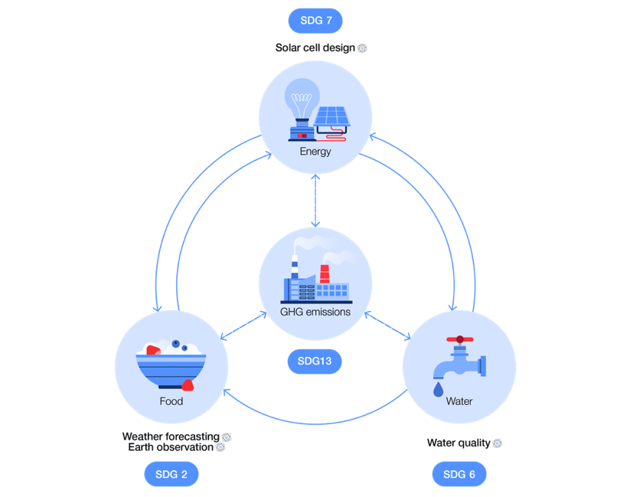

Figure 3: The Water-Food-Energy Nexus. (Source: <https://www.weforum.org/stories/2024/09/how-quantum-technologies-advance-sustainable-development-goals/>)

Climate change has potential wide reaching impacts ranging from agriculture (<https://www.epa.gov/climateimpacts/climate-change-impacts-agriculture-and-food-supply>) to freshwater water resources (<https://www.epa.gov/climateimpacts/climate-change-impacts-freshwater-resources>) and future energy decisions given the ongoing transition away from fossil fuel-driven solutions.

Governments need to consider an *integrated and sustainable management of water, food and energy to balance the needs of people, nature and the economy.* (Source: <https://www.unwater.org/water-facts/water-food-and-energy>)

This highlights the complexity of the underlying issues. If we address and resolve one UN SDG, we inherently (indirectly) have the potential to influence and progress another UN SDG. The converse is also true i.e. if we negatively impact one UN SDG, we may also indirectly impact other areas. Further, it encourages us to consider issues as an interconnected nexus and not stand-alone SDG.

For more examples of a proposed interlinking nexus for each UN SDG, please see for example <https://sdgtoolkit.org/wp-content/uploads/2017/03/A-Nexus-Approach-For-The-SDGs-Interlinkages-between-the-goals-and.pdf>.

## Voluntary nature of UN SDGs

The overall framework for achieving these goals is voluntary. There are no formal penalties for countries who do not meet these targets by 2030. The UN SDGs are not legally binding. Further, there is no official mechanism in place to enforce compliance. However, internal national and external international pressures may encourage countries to address these targets.

Any progress is reported via a Voluntary National Reviews (VNRs). (UN, no date (c)) VNRs are voluntary reports published by countries on their update on the UN SDGs. There are typically published annually, though the number of countries who publish each year varies. For details of the Voluntary National Reviews please see here <https://hlpf.un.org/vnrs>. For a list of VNRs by country per year, please see <https://hlpf.un.org/countries>.

## The UN universal values

Incorporating and implementing changes aligned with the UN SDGs is complicated. To transpose these 17 goals locally, we need to consider *not only economic and social rights, but also civil, political and cultural rights, and the right to development*. (Source: <https://unsdg.un.org/2030-agenda/universal-values>)

Generally, universal values can be seen as a basic set of human needs, applicable to most / all. For example, basic human values as defined by Schwartz in 1992 covers 10 basic values which transpose all cultures. These values includes self-direction, achievement, power, security, benevolence and tradition and have 6 underlying features in common. These values form a circular relationship, which may be compatible with each other as well as conflict. (Sources: <https://i2insights.org/2022/05/10/schwartz-theory-of-basic-values/>, <https://scholarworks.gvsu.edu/cgi/viewcontent.cgi?article=1116&context=orpc>)

Specifically with regards the UN, the universal values can be traced back to 1948, when the UN adopted the Universal Declaration of Human Rights. This declaration covers 30 articles which covers a range of rights and freedoms for all humans, ranging from freedom from discrimination, freedom of expression and right to work. (Sources: <https://www.standup4humanrights.org/en/article.html>, <https://unfoundation.org/blog/post/the-universal-declaration-of-human-rights-is-turning-75-heres-what-you-need-to-know/>)

In mapping the UN SDGs across locally, the universal values act as a foundational platform for us to consider and transform the UN SDGs locally to individuals. *Universal values are what enable the SDGs to be truly transformative, by placing the person and their inherent dignity at the heart of development efforts, empowering all people to become active partners in this endeavour.*

The universal values can be summarised into 3 guiding principles:

1. Human-rights based approach.
2. Leave no one behind.
3. Gender equality and women’s empowerment.

The universal values underpin all work done by the UN in general and are key to being successful at addressing and applying UN SDG progress. It moves the conversation away from target-driven goals to connecting with individuals and making a positive impact for each person across the globe. Any success with UN SDG progress should therefore have these values in mind. (Source: <https://unsdg.un.org/2030-agenda/universal-values>)

## UN-based initiatives to accelerate promotion of development

There are several initiatives led by UN-related agencies to promote acceleration of progress of the UN SDGs and climate change:

* The United Nations Framework Convention on Climate Change’s (UNFCC’s) Loss and Damage Fund, announced at COP27, is an initiative to provide financial support in developing countries in order tackle the impacts of climate change. It is financed mainly by the more developed countries and is based on voluntary financing. For background and details please see <https://unfccc.int/loss-and-damage-fund-joint-interim-secretariat> and <https://unfccc.int/sites/default/files/resource/PILL-HAMMERSLEY-Climate-loss-and-damage-fund.pdf>.

COP 29 resulted in developed countries committing at least USD 300 billion per year to help developing countries tackle climate change issues by 2035. (Source: <https://www.iisd.org/articles/statement/cop-29-moves-needle-on-finance>)

* Superseding the SDG Fund, the Joint SDG Fund has existed since 2017 (Source: <https://unsdg.un.org/sites/default/files/2022-10/System%20Wide%20Evaluation%20of%20the%20Joint%20SDG%20Fund%20FINAL.pdf>). The Joint SDG Fund *aims to mobilise USD 290 million a year for SDG-focused development programmes that rely on strategic financing and integrated policy*. The amount is a fraction of funds committed to climate change and much lower than the estimated total to address the UN SDGs. For more details, including example partnership projects, please see <https://www.jointsdgfund.org>. Please see Section XX for more details on currently projected costs required to resolve the UN SDGs.
* Launched in 2021, the Global Accelerator on Jobs and Social Protection for Just Transitions was launched in September 2021. This initiative aims to accelerate progress by supporting the creation of *decent jobs, primarily in the green, digital and care economies, and to extend social protection to people who are excluded*.  For more details, please visit <https://www.unglobalaccelerator.org>.

## Alternative views of the UN SDG paradigm

Linking the UN SDGs with ESG

Environment, Social and Governance (ESG) is an integrated framework and underlying philosophy for businesses to adopt. The aim for businesses to consider the wider impact on:

1. the natural environment;
2. (external) people and society, including the (internal) labour force; and
3. ethical behaviour.

It is not only important to consider the external influence of ESG on the individual / business, but how the individual / business impacts the wider environment and society.

Though the UN SDGs can be viewed as holistic targets for governments to address, these can be categorised under ESG buckets (Figure 5) which are more focussed on businesses where we are seeing an ongoing shift from voluntary to mandatory requirements such as ESG-related disclosures for companies.

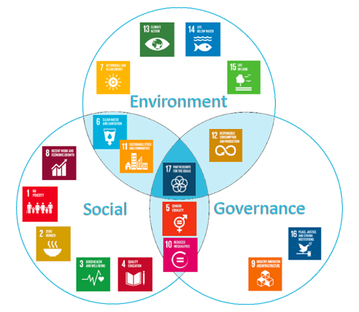

Figure 5: Grouping the UN SDGs by ESG. (Source: <https://www.synergy-cmc.com/esg/>)

Linking the UN SDGs with biodiversity

Presented at the Stockholm EAT Food Forum on 13 June 2016, the UN SDGs were presented with an emphasis on sustainability and healthy food – visually rearranged to be viewed as a wedding cake with the emphasis on the biosphere. See <https://www.stockholmresilience.org/research/research-news/2016-06-14-the-sdgs-wedding-cake.html> for more details and Figure 6. 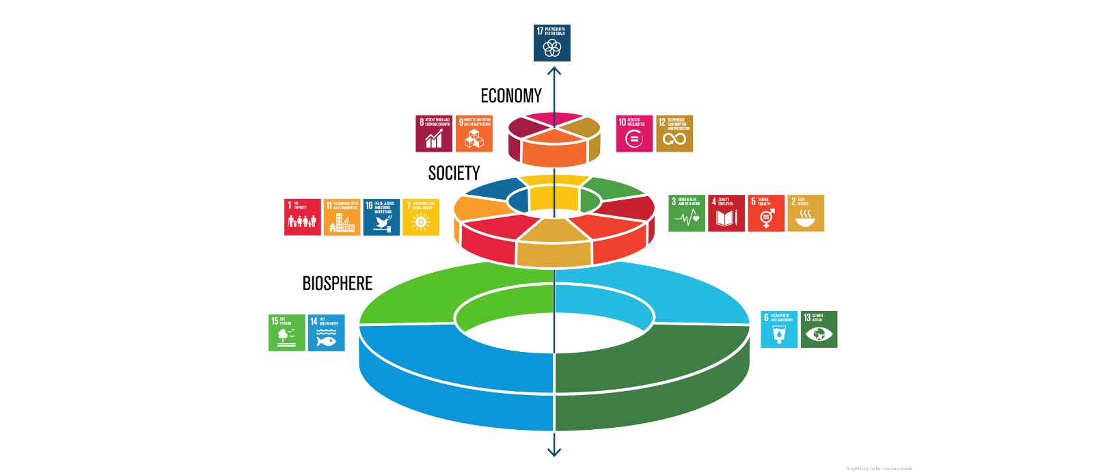

Figure 6: Grouping the UN SDGs by ESG. (Source: <https://www.stockholmresilience.org/research/research-news/2016-06-14-the-sdgs-wedding-cake.html>)

For example, the Kunming-Montreal Global Biodiversity Framework was adopted during the UN Biodiversity Conference COP 15 in 2022 and introduces action-oriented targets by 2030, similar to the UN SDGs, but by placing nature and biodiversity at the heart of its mission. The Kunming-Montreal Global Biodiversity Framework aims to take “urgent action to halt and reverse biodiversity loss to put nature on a path to recovery for the benefit of people and planet”. It introduces 23 action-oriented targets by 2030 grouped into 3 areas (reducing threats to biodiversity, meeting people's needs through sustainable use and benefit-sharing and tools and solutions for implementation and mainstreaming) and 4 underlying goals by 2050 focussing on positive actions against nature and biodiversity loss. For details on the framework please see <https://www.cbd.int/gbf> and <https://www.cbd.int/doc/decisions/cop-15/cop-15-dec-04-en.pdf>.

# Progress update of SDGs

Nearly 10 years in, overall global progress in addressing the 17 UN SDGs has been limited. In a commentary report on the underlying targets published in July 2024 highlighted *many going in reverse*. (Kharas, et al., 2024).

The UN Sustainability Development Goals Report 2024, as shown in Figure 4, highlights only 17% are on target to be met by 2030, 18% as moderate progress, 30% as marginal progress, though 18% classified as stagnated and 17% regressed.

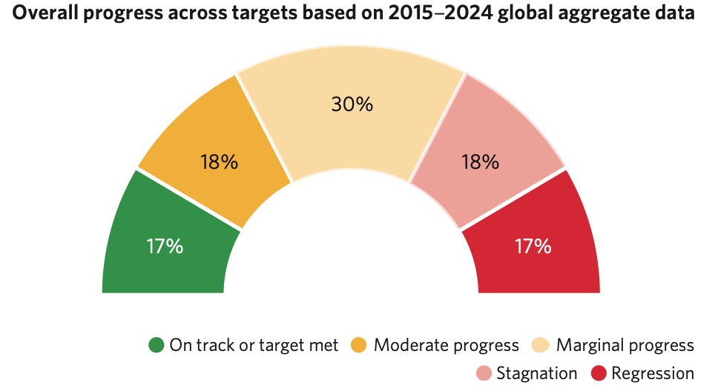

Figure 7 : Summary of global progress to date of UN SDGs. (Source: <https://unstats.un.org/sdgs/report/2024/The-Sustainable-Development-Goals-Report-2024.pdf>)

For a handful of SDGs e.g. GHGs, nutrition, food insecurity, the situation has worsened.

Various studies including a report by Allianz in 2025 highlight the lack of progress / regression in progress for some SDGs in some regions including SDG 2 (Zero Hunger), SDG 8 (Decent Work and Economic Growth) and SDG 16 (Peace, Justice and Strong Institutions)*,* “indicating deep-rooted challenges that hinder progress.” (Source <https://www.allianz.com/content/dam/onemarketing/azcom/Allianz_com/economic-research/publications/specials/en/2025/january/2025-01-21-Insurance_SDG-AZ.pdf>) Other goals, including SDG 1 (No Poverty), SDG 5 (Gender Equality) and SDG 13 (Climate Action) “remain stuck in this middle ground, requiring much more urgent and substantial efforts to reach their targets*.”* (Source <https://www.allianz.com/content/dam/onemarketing/azcom/Allianz_com/economic-research/publications/specials/en/2025/january/2025-01-21-Insurance_SDG-AZ.pdf>)

Some notable statistics from the SDG Report 2024 include:

* 1. Developing countries face a shortly of annual USD 4 trillion investment gap to achieve the UN SDGs.
  2. About 60% of low income countries are experiencing or are at high risk of debt distress.
  3. Current trajectory shows c. 1.1bn people will lack access to basic sanitation by 2030.
  4. There was an annual increase in civilian causalities in armed conflicts by 72%.
  5. There was an improvement in Human Immunodeficient Virus (HIV) incidence comparing pre- and post-2015 rates.
  6. Global food wastage reached just over 1 billion metric tons in 2022.
  7. Overfishing, pollution as well as other factors led to a decrease in the sustainability of global fisher
  8. Small scale farming was responsible for 97% of agriculture-driven deforestation in Africa.

A report by (Kharas, et al., 2024) discusses the potential of an SDG “rescue plan” to ensure that countries are on track to meet their commitments and by 2030. Given that we at mid-point from the adoption of the UN SDGs back in 2015 and the target date of 2030, the voluntary nature of the UN SDGs and the quantum of the annual investment gap mentioned earlier, it is unlikely that these goals will be met in full by 2030 across the majority (if any) of the UN Member State countries.

It is important note that the overall impact of Coronavirus 2019 (COVID 19) pandemic globally and across all UN SDGs. Irrespective of COVID, progress on the UN SDGs was limited and we would be in a similar position today where we would unlikely see UN SDG issues resolved by 2030 across the board. COVID 19 overall has hindered progress, setting back in cases, for the UN SDGs for example increase job losses, limiting access to healthcare during the pandemic, impacting education access for children from low income households and an overall downturn in economic growth. It is projected that COVID 19 could have raised the number of people living in extreme poverty by 44 million by 2030. For more details, please see <https://www.un.org/development/desa/dpad/wp-content/uploads/sites/45/publication/PB_81.pdf> and <https://www.sdgintegration.undp.org/accelerating-development-progressduring-covid-19>. On saying this, arguably it has accelerated the move to cloud solutions for businesses and education alike, making hybrid working environments the “norm” and educational resources more widely accessible for those who have access to the internet.

Figure 8 gives a cosmetic overview of SDG progress per country, with an overall score out of 100 summarising the progress across all 17 UN SDGs. The higher the score, the better the overall progress to date and potential likelihood of delivering on the UN SDGs by 2030. For a current list of country rankings for overall progress in achieving these 17 goals, please see <https://dashboards.sdgindex.org/rankings>. The chart shows the overall UN SDG progress happening mainly in the Americas, Australasia, Europe, the bulk of Asia and north Africa. Broadly, regions lacking in progress include Central America, parts of South America, Central and South Asia, Mongolia and the Far East, as well as the bulk of Africa.

For details underlying the score methodology, please see <https://dashboards.sdgindex.org/chapters/methodology> and <https://www.sustainabledevelopment.report/reports/sdg-index-and-dashboards-2018/>.

For other statistics on progress to date, please see for example the *UN Data Commons for the SDGs* tool created by Google in collaboration with the UN Statistics Division. Please see <https://blog.google/technology/ai/google-ai-data-un-global-goals/> and <https://unstats.un.org/UNSDWebsite/undatacommons/sdgs> for more details.

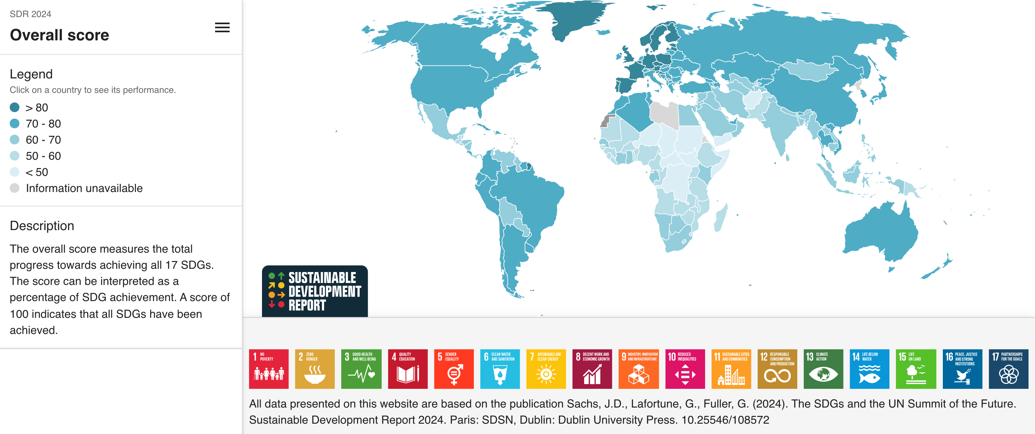

Figure 8: Overview of SDG progress (Source: <https://dashboards.sdgindex.org/map>)

“What gets measured gets prioritised.” (Source: <https://chiefexecutive.net/what-gets-measured-gets-prioritized-but-that-may-not-be-a-good-thing/>) Summarising progress across 17 goals – and 169 underlying targets - into a single index is complex and potentially overly naïve as it removes focus from any underlying detail even if sufficient data has been obtained to monitor progress for each underlying target. The UN SDG Report 2024 states that despite progress being made in terms of the increased number of underlying data points to track and record progress for each target, 39% of the indicators lacked internationally established methodologies or standards and 32% of the indicators had poor data coverage. (Sources: <https://unstats.un.org/sdgs/report/2024/The-Sustainable-Development-GoalReport-2024.pdf>, <https://onlinelibrary.wiley.com/doi/abs/10.1002/sd.1735>) For more details on the underlying methodology used for the UN SDG index, please see <https://dashboards.sdgindex.org/chapters/methodology>.

For alternative index measures, please see Appendix 3.

Other useful resources to view UN SDG progress include:

* The UN Sustainable Development Goals Report 2024 <https://unstats.un.org/sdgs/report/2024/The-Sustainable-Development-Goals-Report-2024.pdf>
* A collaborative effort by researchers at the University of Oxford and the non-profit organisation Global Change Data Lab, which summarises progress per SDG <https://ourworldindata.org/sdgs>.
* Interactive maps and country rankings by the SDG Transformation Center <https://datahub.sdgtransformationcenter.org>.
* A list of individual country progress scores and detailed country commentary <https://dashboards.sdgindex.org>.
* For further commentary on specific countries published via the IFoA blog site <https://blog.actuaries.org.uk>.

## Recap on recent UN Summit in 2024

The UN Summit of the Future took place in September 2024, which includes heads of state, government officials and representatives of NGOs. World leaders adopted the “Pact for the Future” which consists of 56 actions designed to “turbocharge” progress for the UN SDGs, in particular on issues surrounding “on issues around peace and security, global governance, climate change, digital cooperation, human rights, gender, youth and future generations.”   
(Source: <https://www.weforum.org/stories/2024/09/un-summit-future-sdgs/>)

The Pact covers :

* The first multilateral recommitment within the past 10 years which works towards nuclear disarmament.
* Consideration of a framework which measures sustainable development progress beyond GDP.
* Consideration to close the financing gap for developing countries.

For more details, please see <https://www.weforum.org/stories/2024/09/un-summit-future-sdgs/>.

## Expected UN SDG progress as at 2030

Overall, the UN SDGs are unlikely to be met by 2030 globally. This is explored for example in which uses machine learning techniques (ARIMAX and Linear Regression smoothed by Holt-Winters' multiplicative technique) to forecast the UN SDG score per country to 2030.

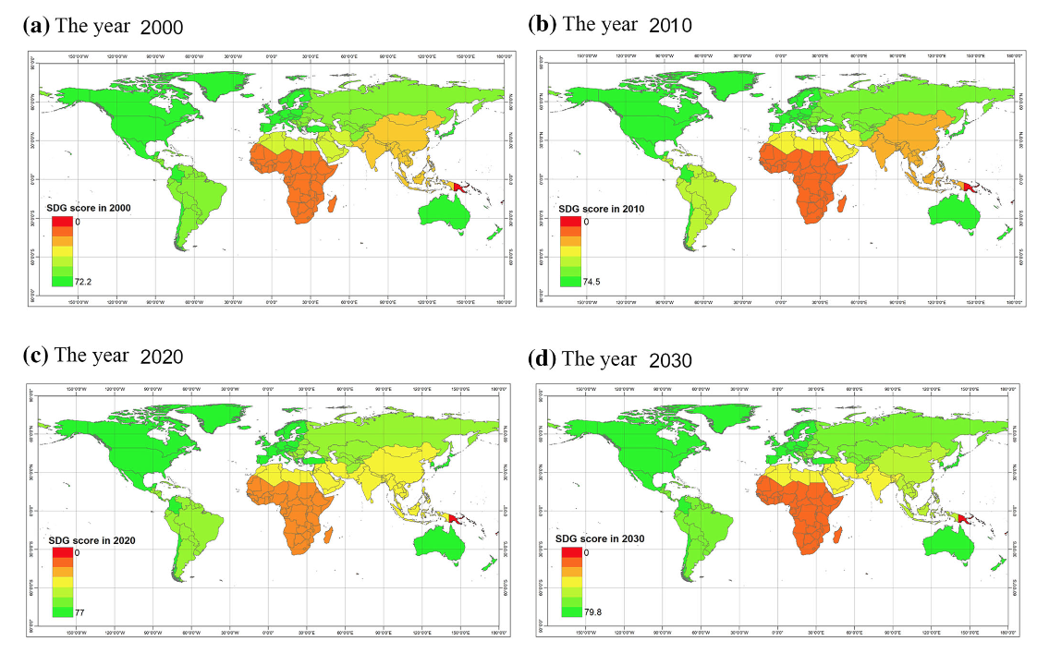

Figure 9: Predictive UN SDG score around the world by 2030 based on machine learning techniques. (Source: (Chenary, et al., 2023))

As can be seen in Figure 6, areas in Africa and Asia are most likely to not reach these targets based on this paper (areas receiving a low score and indicated in differing shades of red, orange and yellow) though it predicts further progress to be made in China, South Asia and Latin America.

# Addressing the lack of progress

## Potential reasons for current lack of global progress on the UN SDGs

As discussed earlier, progress is severely lacking at a global level due to several factors including:

1. Not addressing the root causes. Global and societal inequalities for example may be based on historic and current global debts as well as trade imbalances. Structural imbalances within society maybe accentuated further through a society set up on capitalism.

For example, the UN reported in 2024 that “3.3 billion people live in countries that spend more on interest payments than on either education or health.” (Source: <https://unctad.org/publication/world-of-debt>) See Section 2.15 for more details on this.

Some imbalances are deeply rooted after a long history of social acceptance of the inequalities, and may be embedded in the underlying fabric of society. For example, South Africa received the worst ranking globally for inequality in 2023 based on a Gini coefficient score. Though progress has been made since the end of Apartheid in 1994, such as a new constitution, freedom of movement, land ownership and a noticeable increase in school goers across all ethnicities, the root cause of much of the current structural inequalities is due to years of historic Apartheid and colonialism. (Source: XX)

Hence, is a target date of 2030 realistic in the first place?

Do the UN SDGs sufficiently address global inequalities between countries, given that the remit is for governments to address issues within their own country? Do we need to consider ourselves as a global community and global society, with the aim of eradicating inequalities and poverty, and collectively take action against such issues as climate change?

Going further, can some of these inequalities ever be eradicated irrespective of how hard we try, as arguably bias, discrimination and putting oneself above others is part of any human psyche.

To make meaningful changes, a change in mindset on an individual and a societal level is required.

Is the underlying universal value of the UN SDGs of “leave no one behind” an unrealistic and unachievable target? (Source <https://unsdg.un.org/2030-agenda/universal-values/leave-no-one-behind>)

1. Complexities in transposing the UN SDGs whilst maintaining local cultural values. For examples does the view of gender equality differ from an external standpoint when viewed in the West versus in the Middle East? Does the idea of smart cities ignore local businesses which have been part of the community for several years and have historic understanding and value within the local community?

Local cultural values are not set out as one of the 17 UN SDG goals, though are referenced with some of the underlying targets e.g. target 4.7 under education refers to “appreciation of cultural diversity.” (Source: <https://www.globalgoals.org/goals/4-quality-education/>)

This is explored further in *Culture in the Sustainable Development Goals: A guide for local action* published in 2021 by the UCLG which considers culture for each of the UN SDGs and discusses potential cultural values for cities to consider when integrating changes aligned with the UN SDGs. For more details, please see <https://www.agenda21culture.net/sites/default/files/culturesdgs_web_en.pdf>.

1. General financing challenges to address some of these problems. For example, climate change has a Loss and Damage Fund (see Section XX) to help less developed countries progress development.

Arguably less countries additional funding is required to play “catch up”. There is limited flow of capital between developed to least developed countries.

For example, the UN Conference on Trade and Development’s World Investment Report 2023 highlights that developing countries face a widening annual investment deficit as they work to achieve the SDGs by 2030 – which has grown to around USD 4 trillion per year from around USD 2.5 trillion in 2015. (Source: <https://www.ubs.com/global/en/sustainability-impact/sustainability-insights/2023/sdgs-an-assessment-of-progress-and-challenges.html>)

1. The voluntary nature of the UN SDGs and lack of accountability. There are no penalties or ways to enforce governments to act beyond international peer pressure.
2. The recent 2024 UN SDG report mentions the difficulty of measuring some of the SDG targets given the lack of data / metrics for some, despite progress in this area over the past few years. (Source: <https://unstats.un.org/sdgs/report/2024/>) Given the amount of data points required, there were some countries excluded from the final 2024 UN SDG index score e.g. Dominica, Libya and Tonga. (Source: <https://dashboards.sdgindex.org/chapters/methodology>)

Further, given the number and range of UN SDG targets, this encourages the disaggregation of underlying data. (Source: <https://unstats.un.org/sdgs/files/meetings/iaeg-sdgs-meeting-07/Human%20Rights%20Standards%20for%20Data%20Disaggregation%20-%20OHCHR%20-%20Background%20Document.pdf>) This may within itself result in a potential disproportionate cost involved in collecting and monitoring some of these indicators, which arguably could be better spent on actioning solutions.

Similarly, some critics suggesting a move away from GDP to be a fairer measure of progress. (Source: <https://www.sciencedirect.com/science/article/pii/S1462901123000370?via%3Dihub>) This is explored further in Section XX.

1. There are potentially too many targets making it difficult for countries and governments to address, prioritise and resolve, potential conflicting priorities between goals and trade-offs with prioritisation – at least in the short term. For example, efforts to address SDG 1 (no poverty) might involve economic activities which increase carbon emissions, whilst stringent climate actions in line with SDG 13 (climate action) may limit economic opportunities for the poor. Similarly, short-term aims of addressing SDG 2 (zero hunger) of expanding agricultural land may lead to loss of biodiversity and increased deforestation. This may conflict with SDG 15 (life on land), which focusses on conversation of biodiversity and protection of natural habitats.

See Section XX for more discussion on the above.

1. Lack of engangement between government vs private sector vs society vs individual (see later)

## COVID-19 and the Great Reset

As discussed earlier in Section 3, COVID-19 has had a negative impact on progress on some of the UN SDGs. For example, it is projected that COVID 19 could have raised the number of people living in extreme poverty by 44 million by 2030. This is explored further in <https://sdgintegration.undp.org/sites/default/files/Flagship_1.pdf>.

In 2020, the World Economic Forum (WEF) proposed the Great Reset which aims to reshape the global economic and social systems, focusing on addressing inequalities, sustainability and a resilient future. For more details, please see <https://www.amazon.com/COVID-19-Great-Reset-Klaus-Schwab/dp/2940631123>.

## Conferences to address underlying issues

Currently, there are individual annual Conference of the Parties (CoPs) focussed on climate change, biodiversity and desertification – commonly known as the “tri-COP”. These discuss challenges and solutions surrounding each topic with key stakeholders including heads of state and UN representatives, with the aim of reaching key agreement and commitments to next steps.

There is no real equivalent for other SDGs – the closest being the High-Level Political Forum (HLPF) which discusses SDG progress across all 17 goal. The HLPF meets annually each year for 8 days, under the auspices of the Economic and Social Council (ECOSOC) for eight days, including a three-day ministerial segment to discuss progress on the UN SDGs and discusses the Voluntary National Review updates for countries present. Each fourth year, the Forum is rebranded as the “UN SDG Summit” includes representation from heads of state and governments. For more details, on HLPF please see <https://hlpf.un.org>.

There is a broader question of if similar COP are required for each UN SDG, beyond climate change, biodiversity and desertification to help accelerate progress and give sufficient global promotion to these issues, noting the nexus concept already mentioned earlier i.e. if we resolve climate change, then there is a ripple effect on other UN SDGs.

## Economic cost to achieve UNSDGs by 2030

In 2023, the UN Conference on Trade and Development (UNCTAD) proposed 6 transition pathways which covered SDG 1 to SDG 15 (and excluded SDG 16 and 17) – see Figure 10. The proposed pathways included social protection and decent jobs, transformed education system, digital transformation, energy access and affordability, food systems, and climate change, biodiversity loss and pollution. The pathways were overlapping i.e. the same SDG mapped across to several pathways.

As part of the analysis, UNCTAD tried to quantify the costs involved in achieving UN SDG progress by 2030. This analysis covered nearly 50 UN SDG indicators across 90 countries, including 48 developing countries – broadly covering 75% of the world’s population. (Source: <https://sdg.iisd.org/news/unctad-puts-a-price-tag-on-sdgs/>)

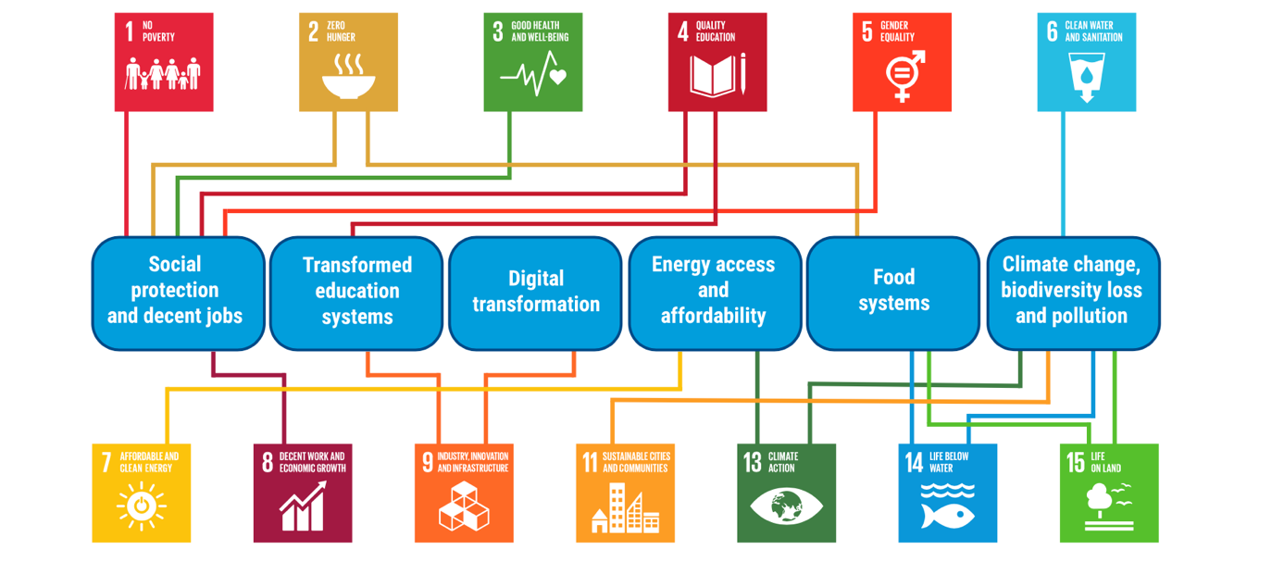

Figure 10: Proposed “transition pathways” for sustainable development by UNCTAD

The study suggests that there are synergy savings i.e. costs spend on improving one SDG will naturally have a secondary positive impact on improving other related SDGs. Though the cost varies by pathway, when covering all 48 developed countries (broadly Canada, the USA, Europe, Russia, Japan and Australia) the cost of achieving each pathway by 2030 is around USD 6.9 trillion to USD 7.6 trillion. For more details, please see <https://unctad.org/sdg-costing/about>. The cost of gender equality and food systems pathways were at the upper end of the cost range, whilst social protection and decent jobs, climate change and digital transformation at the lower end of the cost range.

Given the shortfall, and the wider responsibility, there is a need for private sector investment to assist public sector investment. (Sources: <https://www.ubs.com/global/en/sustainability-impact/sustainability-insights/2023/sdgs-an-assessment-of-progress-and-challenges.html> and <https://unctad.org/sdg-costing>) This is explored further in Section 6 of this paper.

Breaking down these costs to individual SDGs is challenging, and potentially given the interconnectedness of UN SDGs as discussed earlier via a nexus lens, a pathway approach grouped several SDGs may be more appropriate – both in terms of quantifying the impact and looking to provide holistic solutions.

Remittances

There is a broader question of whether there needs to be a larger flow of capital from wealthier nations to developing countries. One such related solution are remittances. Remittances are flows of cashflows from migrant workers to their home country e.g. to help family still residing in their home country. In 2023, remittances totalled around USD 656 billion and represented around 3% of GDP in over 60 countries. (Source: <https://www.worldbank.org/en/topic/migration/brief/remittances-knomad>)

## Financing debt holding emerging markets and developing economies

It is estimated that several trillion dollars are required for emerging markets and developing economies (EMDEs) to achieve their UN SDGs. A report by the UN Trade & Development has stated that developing countries are spending more paying interest on debts issued in the international markets than on education or health (<https://unctad.org/publication/world-of-debt>) with bonds yields issued by countries in Africa being around 4 times higher than the US over the period 2020 to 2024.

Currently, EMDEs are being negatively impacted by a “4th wave of global debt”. (Source <https://www.weforum.org/stories/2021/01/covid-global-debt-history-world-bank-imf/>). The latest wave of global debt has been around since 2010, driven in part by the low interest rates caused by quantitative easing policies to address the financial crisis in 2008, and extended due to COVID with countries borrowing increased amounts to keep economies afloat. (<https://www.ssga.com/uk/en_gb/institutional/insights/tidal-wave-global-debt>, <https://www.weforum.org/stories/2021/01/covid-global-debt-history-world-bank-imf/>). The total debt for EMDEs (both public and private sector) rose to nearly 170% of GDP by the end of 2018. (Source: <https://thedocs.worldbank.org/en/doc/9eeb21e4426d6c3113f9bed45853e160-0350012021/related/Global-waves-of-debt-Chapter-4.pdf>)

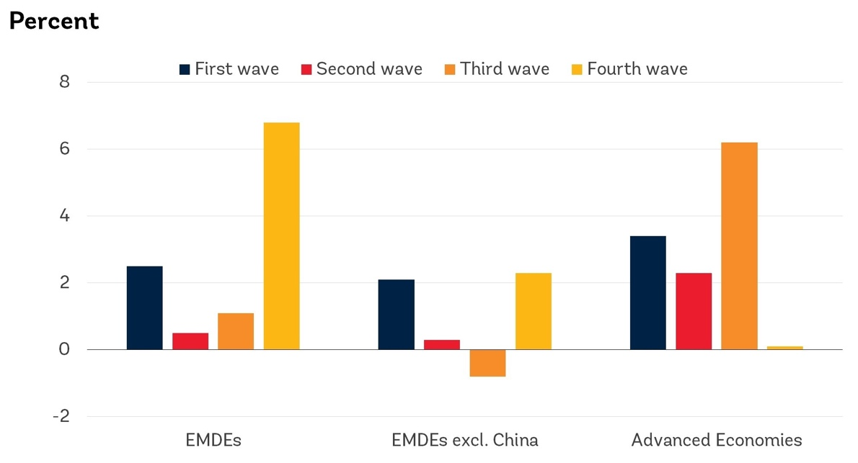

Figure XX: Chart which shows the percent (?) of debt spit by EMDEs, EMDEs excluding China and Advanced Economies. (Source: <https://www.weforum.org/stories/2021/01/covid-global-debt-history-world-bank-imf/>)

Arguably, funds spent financing existing debts are being redirected from potential UN SDG progress e.g. addressing infrastructure issues to deal with education, healthcare and other infrastructure changes.

There has been a historic pattern at the end of each prior global waves of debt – the first which ended in the early 1980s resulted in the Latin American Debt Crisis, the second wave which ended in the early 2000s resulted in the Asian Financial Crisis and in 2008 which resulted in the global financial crisis and increase in sovereign debt. Such financial crises may lead to policy trade-offs and e.g. cuts in public spending on healthcare, education and general infrastructure progress which in turn hinders UN SDG progress locally. Given the repeated pattern of some form of wider financial crisis which follows a global wave of debt, it is more than likely a similar crisis may follow for the 4th wave of global debt which may be more pronounced for EMDEs and hence hinder any local UN SDG progress.

For an overview of government debt across the world from 1953 to 2023 as a percentage of GDP, please see IMF’s DataMapper <https://www.imf.org/external/datamapper/CG_DEBT_GDP@GDD/SWE>. For more details on the fourth wave of global debt please see <https://thedocs.worldbank.org/en/doc/771461575650678441-0050022019/original/DebtChapter4.pdf>.

* Private debt

## Global North versus Global South

Though there are not a definitive definition, a common definition of the Global North and Global South is based on the Brandt Line discussed in the 1980 publication *North-South: A Programme for Survival*, written by a committee led by former German chancellor Willy Brandt. The report highlighted the stark economic differences between countries in the Global North and Global South, and proposed an imaginary line (the Brandt Line) which separates these 2 regions - the richer / more developed north and poorer / less developed south. For more details, please see <https://commonslibrary.parliament.uk/what-is-the-global-south/>.

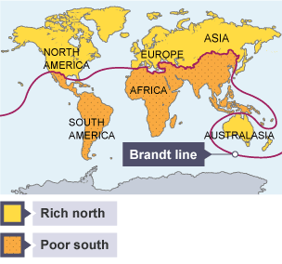

Figure XX: Visualisation of Global North and Global South (Source: <https://www.bbc.co.uk/bitesize/guides/zq8gj6f/revision/1>)

Though the Brandt Line may not be currently reflective of economic disparities around the world, for example with the progress of India and China as global economic powers, underpinning the Brandt Line and proposed two regional divides is the discussion around potential global inequalities which have deep historical roots, for example where the “core” based in the Global North benefits and exploits the “periphery” based in the Global South. (Source: <https://www.cambridge.org/core/journals/review-of-international-studies/article/brandt-line-after-forty-years-the-more-northsouth-relations-change-the-more-they-stay-the-same/8646CE553D2F986BD33B67352FFC5814>) This is further explored by Stephan Lessenich who proposed the concept of “externalisation society” where affluent societies maintain their lifestyles by outsourcing the cost of consumption and production to other regions (i.e. Global South). (Source: <http://nixtlaverse.nixtla.io>)

The lack of economic and social progress in the Global South can be attributed to the core-periphery concept, where typically the core (Global North) extract resources from the periphery (Global South) to benefit the core with little improvement or benefit to the those living in the periphery. (Source: Slow Down, The Degrowth Manifesto – Kohei Saito) Similarly, aspects of the debt and lack of development in the Global South can in part be traced back to colonial debt, and arguably neo-colonial debt via continued loans from the Global North which maintains this disparity between the Global North and Global South. (Source: <https://debtjustice.org.uk/wp-content/uploads/2022/08/Colonialism-and-Debt-briefing.pdf>)

For example, in the early 1800s, Haiti was imposed with an indemnity of 150 million gold francs (which was later reduced to 90 million) in exchange for recognition of independence which plunged the country into decades of debt. (Source: <https://www.bbc.co.uk/news/articles/c39j7k1n48mo>)

The Drain of Wealth Theory proposed as early as the late 19th century by Dadabhai Naoroji and refers to a systematic transfer of wealth from India to colonial Britain over a period of just under 200 years by extracted various wealth from India by range of methods including exporting raw materials, levying high taxes and de-industrialisation of the Indian economy. (Source: <https://vajiramandravi.com/upsc-exam/drain-of-wealth-theory/>, <https://www.nextias.com/blog/drain-of-wealth-theory/>) India’s share of global GDP decreased over this period from c.24% to c.4%. (Source: <https://timesofindia.indiatimes.com/blogs/Swaminomics/raj-review-did-british-rule-really-impoverish-india/>)

Beyond the economic disparities, social inequalities within countries can be traced back in cases to lingering colonial influences for example in South Africa.

Though the UN SDGs are aimed at governments to action for each country, should UN SDG 10 (reduced inequalities) and the underlying core principle of “leave no one behind” be expanded between countries across the globe i.e. between the Global North and the Global South?

* Examples of colonial debt?
* <https://en.wikipedia.org/wiki/Ecological_footprint>
* <https://www.iied.org/worlds-least-developed-countries-spend-twice-much-servicing-debts-they-receive-climate-finance>

# Wider considerations

## Set up to fail, political agenda, alternatives to SDGs?

* Measurings tied into GDP

Wider failings

* <https://www.theguardian.com/sustainable-business/2015/jul/21/capitalism-alternatives-sustainable-development-failing>
* <https://www.developmentresearch.eu/?p=762>
* <https://pakobserver.net/post-colonial-power-structures-challenges-of-achieving-sdgs/>
* <https://repository.londonmet.ac.uk/9307/>
* <https://journals.openedition.org/ried/9171>
* <https://www.wri.org/insights/international-climate-finance-which-countries-should-pay>
* <https://sdg.iisd.org/commentary/guest-articles/are-we-serious-about-achieving-the-sdgs-a-statisticians-perspective/>
* <https://www.bradley.com/insights/publications/2024/03/esg-backlash-in-the-us-and-europe-shifting-sentiments-and-regulations>
* <https://en.wikipedia.org/wiki/New_International_Economic_Order>
* <https://ourworld.unu.edu/en/who-should-pay-climate-change-costs>
* <https://en.wikipedia.org/wiki/Tragedy_of_the_commons>
* <https://en.wikipedia.org/wiki/Green_imperialism>
* <https://publicadministration.desa.un.org/sites/default/files/old-site/Images/WorldPublicSector/Chapter%202.pdf>

## Moving away from GDP

* <https://link.springer.com/chapter/10.1007/978-3-031-30308-1_3#Sec7>
* <https://www.policyforum.net/its-time-to-move-beyond-a-western-understanding-of-development/>
* <https://medium.com/horizons-institute/what-comes-after-the-un-sustainable-development-goals-a632d768a58a>
* <https://www.ncbi.nlm.nih.gov/pmc/articles/PMC9295117/>
* <https://earth.org/op-ed-the-un-sustainable-development-goals-are-unsustainable-heres-why-the-world-needs-alternative-approaches/>
* <https://unsceb.org/sites/default/files/2023-01/Valuing%20What%20Counts%20-%20UN%20System-wide%20Contribution%20on%20Beyond%20GDP%20%28advance%20unedited%29.pdf>
* <https://blogs.worldbank.org/en/opendata/are-we-there-yet-many-countries-dont-report-progress-all-sdgs-according-world-banks-new>
* Local culture and individualism?
  + <https://sdghelpdesk.unescap.org/e-library/localizing-sdgs-strategies-and-plans>
  + <https://www.agenda21culture.net/sites/default/files/culturesdgs_web_en.pdf>

Alternatives to GDP to include impact on nature?

Do we need to move away from GDP as an indicator and driver for UN SDG development? For example, increased GDP may result in improved spend on education and health infrastructure. However, it may also result in environmental degradation, increased inequality within society and between countries and lead to unsustainable consumption practices if not managed responsibly.

In 2016, the World Economic Forum focussed on a range of discussions which posed the question if GDP is relevant in day and age? For more details, please see for example <https://www.weforum.org/focus/beyond-gdp/>

<https://www.weforum.org/podcasts/stakeholder-capitalism/episodes/stakeholder-capitalism-beyond-gdp/>

World Economic Forum’s chief economist Jennifer Blanke explained that “GDP is a partial, short-term measure, whereas the world needs more wide-ranging and responsible instruments to inform the way we build the economies of the future.” Further she explains that GDP overlooks the following 3 questions: is growth fair, is it green, and is it improving our lives? (Source: <https://www.weforum.org/stories/2016/04/beyond-gdp-is-it-time-to-rethink-the-way-we-measure-growth/>) For further conversations surrounding beyond GDP by WEF, please visit <https://www.weforum.org/focus/beyond-gdp/>.

Alternative measures which broaden the scope of GDP to incorporate aspects of the UN SDGs include:

* Green GDP, which adjusts traditional GDP to incorporate traditional environmental variables. (Source: <https://vajiramandravi.com/upsc-exam/green-gdp/>)
* Natural Capital Accounting
  + System of Environmental Economic Accounting (SEEA) <https://seea.un.org>
* Economics of Ecosystems and Biodiversity
* The Dashboard of Sustainability
* <https://www.foreignaffairs.com/how-get-right-kind-growth>
* <https://www.nobelprize.org/uploads/2018/10/nordhaus-lecture.pdf>
* <https://academic.oup.com/ej/pages/the-economics-of-income-and-wealth-distribution>
* <https://www.visualcapitalist.com/global-wealth-distribution/>
* <https://en.wikipedia.org/wiki/Netherlands_fallacy>
* Jevons paradox

Alternative measures such as Human Development Index and Social Progress Index are explored in Appendix 3.

## Alternative economic models

### Doughnut economics

Suggested in her paper in 2012 *A safe and just space for humanity*, *Can we live within the doughnut?* and further explored in her follow-up in 2017 *Doughnut Economics: seven ways to think like a 21st century economist*, Kate Raworth suggest an economic model based on the shape of a doughnut.

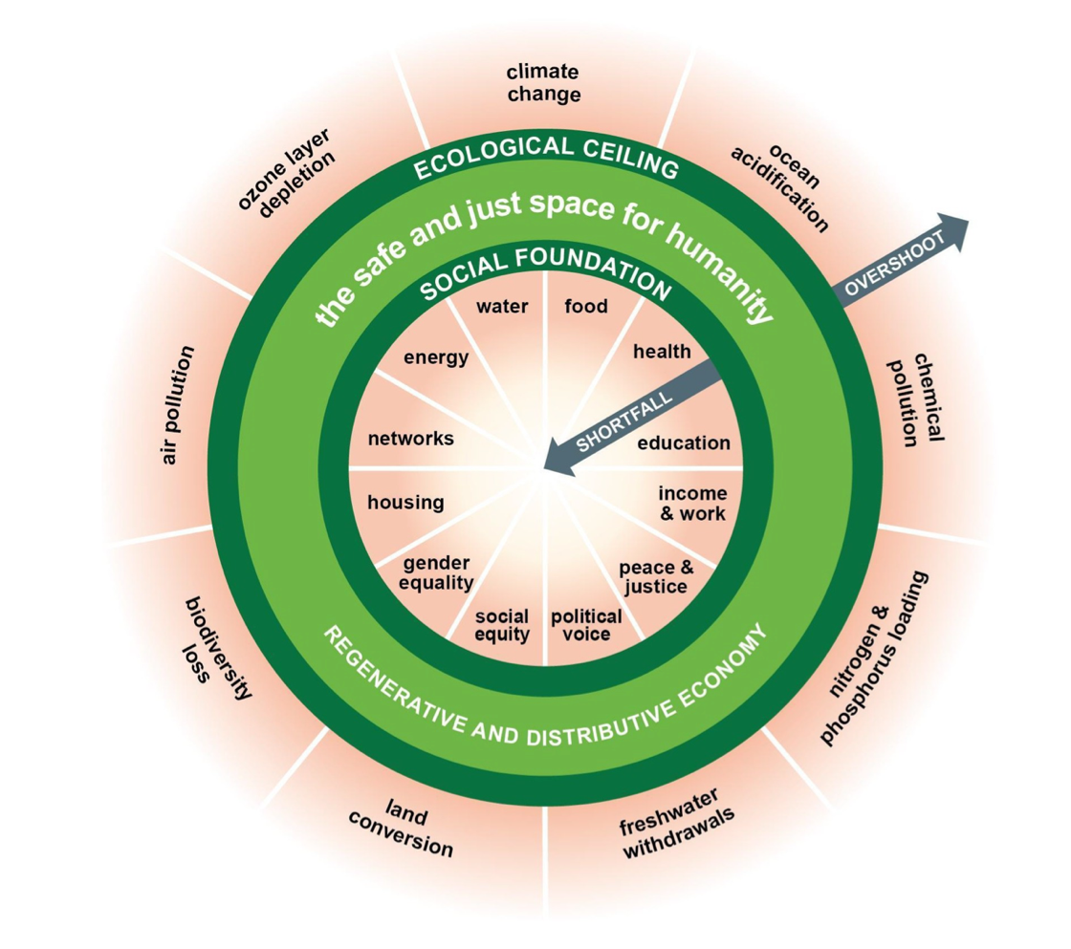

Figure XX: Doughnut xX (Source: <https://committees.parliament.uk/writtenevidence/43722/pdf/>)

For more details on this, please visit <https://doughnuteconomics.org>.

* <https://doughnuteconomics.org/news/new-analysis-reveals-that-no-country-is-living-in-the-doughnut>
* <https://en.wikipedia.org/wiki/Doughnut_(economic_model)>
* <https://communities.springernature.com/posts/draft>
* <https://committees.parliament.uk/writtenevidence/43722/pdf/>
* Updated doughnutc
* <https://goodlife.leeds.ac.uk/related-research/doughnut-shaped-recovery/> 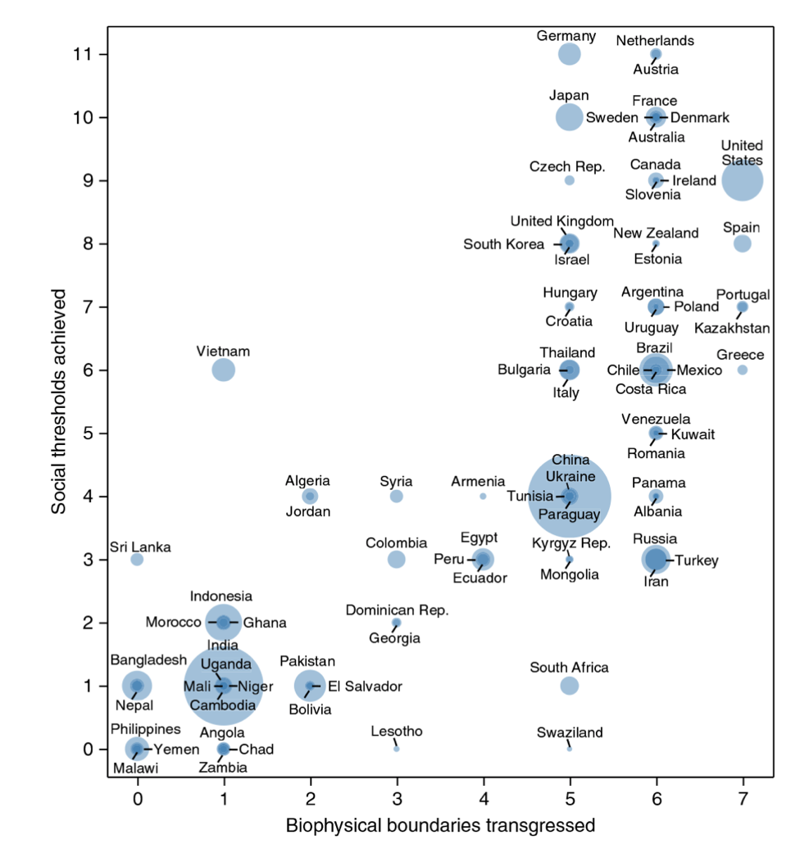
* <https://earthbound.report/2018/02/13/which-countries-are-within-the-doughnut/>

## Dasgupta review

* <https://www.gov.uk/government/publications/final-report-the-economics-of-biodiversity-the-dasgupta-review>
* Adjust GDP for CO2?

## Rethinking of current economic frameworks?

Popularised by Garrett Hardin in his 1968 essay, the “Tragedy of the Commons” discusses the problem of individuals overusing limited resources for their own gains which in turn leads to harm to the group by overuse. Examples include overfishing or deforestations. (Source: <https://math.uchicago.edu/~shmuel/Modeling/Hardin,%20Tragedy%20of%20the%20Commons.pdf>)

Green capitalism or eco-capitalism looks to resolve environmental challenges whilst working within the framework of capitalism. Core principles of green capitalism include attempt to resolve climate crisis in a way which minimises disruption to the economy and wealth distribution; and promoting decarbonisation whilst promoting opportunities of profit. (Source: <https://www.energymonitor.ai/finance/sustainable-finance/what-is-green-capitalism-and-can-it-tackle-the-climate-crisis/>)

Responsible capitalism which looks to balance profit making and ethical, social and environmental responsibilities. (Source: <https://responsible-capitalism.org/what-is-responsible-capitalism/>)

* Green growth / doughnut economics / post-growth economics / ecological economics / steady-state economy / climate justice / commons-based economy / bioregionalism / regenerative economy / Green Keynesianism
* <https://en.wikipedia.org/wiki/Metabolic_rift>
* <https://www.devstud.org.uk/decolonising-development-studies/>
* <https://www.scirp.org/journal/paperinformation?paperid=113806>
* <https://foreignpolicy.com/2024/08/16/climate-change-central-banks-credit-guidance/>
* <https://www.sciencedirect.com/topics/social-sciences/economic-complexity>
* <https://academic.oup.com/ej/pages/the-economics-of-income-and-wealth-distribution>

For example, this idea is further explored in *Slow Down: Capital in the Anthropocene* by Kohei Saito who argues that fundamentally any climate solution, and inherently sustainability solution, is flawed as the underlying premiss is based on capitalism, where capitalism is fundamentally centred on profitability and results in overuse of resources – many of which are limited such as raw materials. An alternative proposed by the author is the concept of “degrowth communism” which shifts the driver from overuse to responsible / sustainable use and moving the focus from the individual to the wider group or society though via improved workers' cooperatives, democratic change and strong social welfare systems rather than centralised state control. (Source: <https://www.theguardian.com/world/2022/sep/09/a-new-way-of-life-the-marxist-post-capitalist-green-manifesto-captivating-japan>)

The term degrowth was coined in 1972 by Austrian-French social philosopher André Gorz, and started to gain popularity from the early 2000s and argues that the current model of economic growth by society is not sustainable. The overall aim of degrowth is to scale back on global consumption of underlying resources – many of which are limited. Similarly, proponents of degrowth have backed the move away from GDP as a fundamental measure of economic progress and success. (Source: <https://www.weforum.org/stories/2022/06/what-is-degrowth-economics-climate-change/>) The term itself is moving towards a social movement. (Source: <https://journals.sagepub.com/doi/abs/10.3197/096327113X13581561725194>) For the annual conference on degrowth, please see <https://isee-degrowth2025.no>.

## Spillovers

“Positive and negative spillovers must be understood, measured, and carefully managed since countries cannot achieve the SDGs if spillovers from other countries counteract their effort.” (Source: <https://sdgtransformationcenter.org/spillovers>)

Spillover effects can be both positive or negative effects of one country on another and hence impact a country’s ability to achieve their own UN SDGs. Given the highly interdependent world we live in with global supply chains and financial markets, (see Figure X as an example, which shows the negative spillovers on water and air), “one country's actions generate benefits or impose costs on another country that are not reflected in market prices, and therefore are not "internalised" by the actions of consumers and producers.”

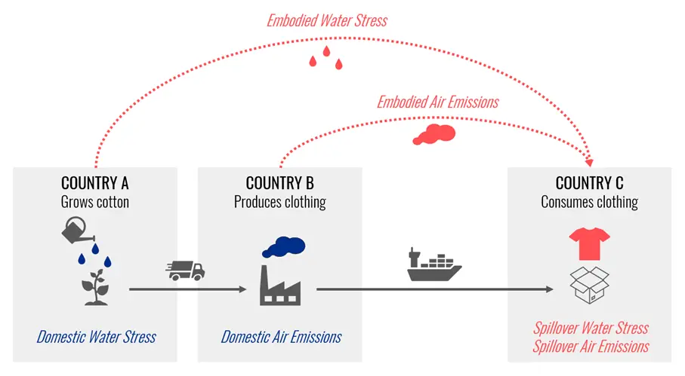

Figure XX: Example spillover (Source: <https://sdgtransformationcenter.org/spillovers>)

Examples of a negative spillovers include:

* Demand for palm oil in one country which results in deforestation in the country providing the commodity. (Source: <https://sdgtransformationcenter.org/spillovers>)
* 40% of greenhouse gases (GHGs) “emitted” by the EU are actually generated outside of the EU. [EXPLAIN] (Source: <https://sdg-action.org/how-to-curb-negative-international-spillovers/>)
* The EU’s consumption is responsible for around 17% of tropical deforestation worldwide. (Source: <https://sdg-action.org/how-to-curb-negative-international-spillovers/>)
* On the whole, between 2010 and 2018, high-income nations were accountable for over 80% of the cumulative imported CO₂ emissions. (Source: <https://sdg-action.org/how-to-curb-negative-international-spillovers/>)
* It is estimated that around 22% of global CO2 emissions are from goods consumed in one country but derived from another. (Source: <https://www.climatechangenews.com/2022/04/08/sweden-set-to-be-worlds-first-country-to-target-consumption-based-emission-cuts/>)

For a visual overview of spillovers, please see Figure XX which a global overview of spillovers which is based on the “Environmental Impact Index” – created by a joint by Sustainable Development Solutions Network (SDSN) and the Yale Center for Environmental Law & Policy. The underlying index itself is based on a emissions including CO2, scarce water consumption and fatal accidents at work. Broadly, the Global North (i.e. northern America, Europe, Russia, Australia and parts of the Middle East and parts of South America) show a larger negative spillovers.

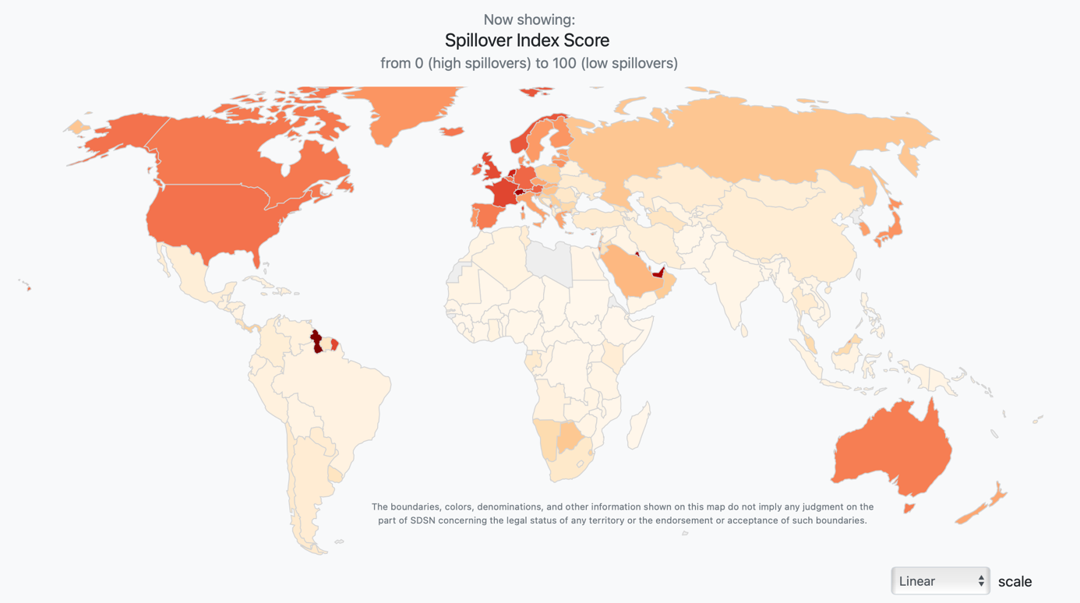

Figure XX: Global overview of spillovers – based on 2020 score and “linear” scale. The darker the shade of the colouring, shows the higher the negative overall negative spillover. (Source: <https://spillovers.environmentalimpact.global/#/>)

This is further explored in Figure XX which shows the net import / export of CO2  to / from a country.

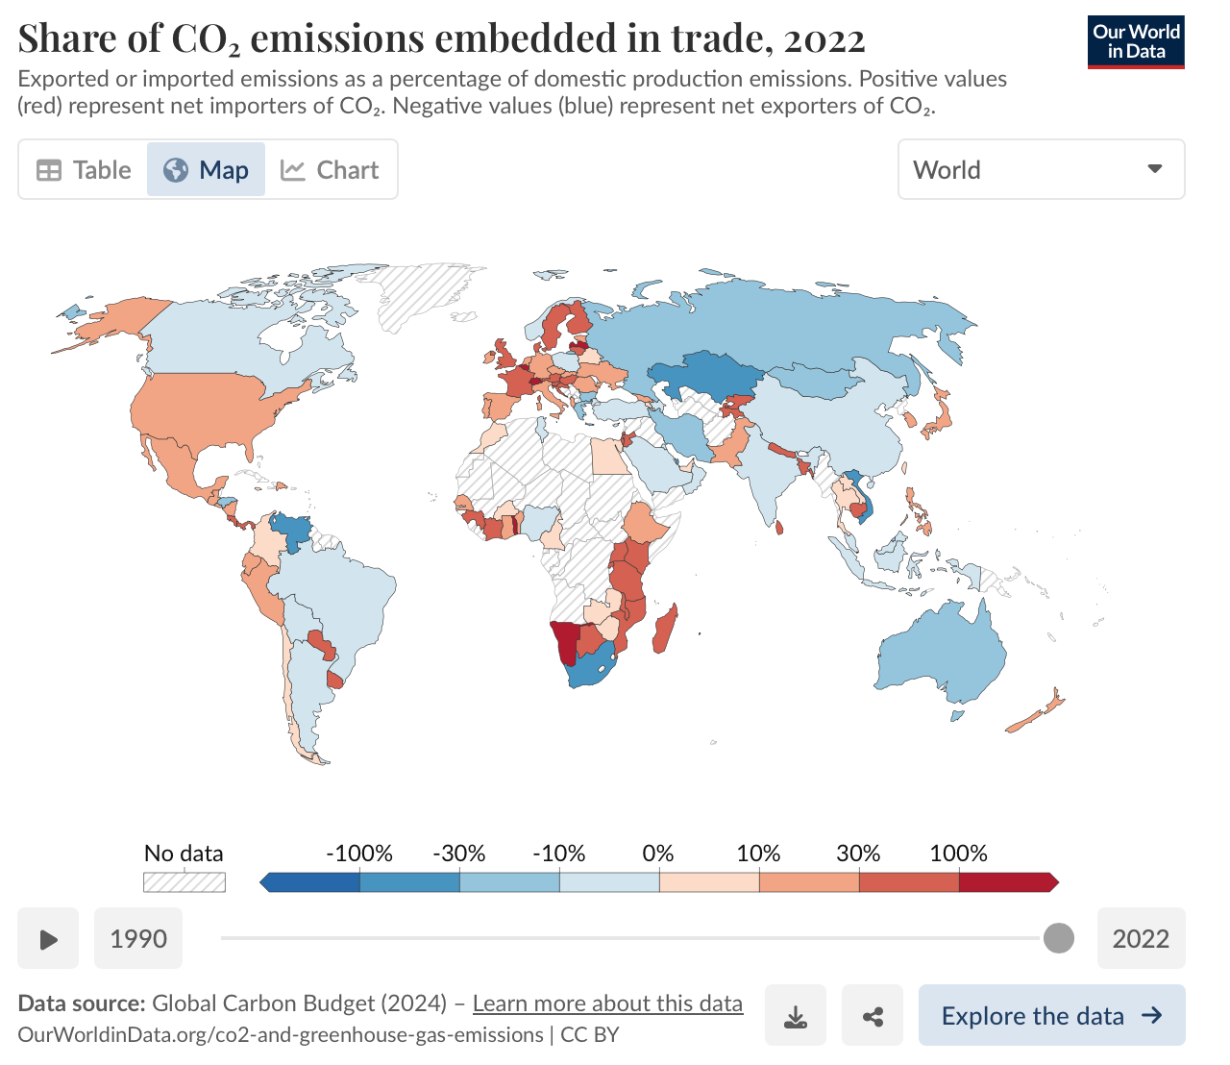

Figure XX: Share of CO₂ emissions embedded in trade, 2022. Exported or imported emissions as a percentage of domestic production emissions. Positive values (red) represent net importers of CO₂. Negative values (blue) represent net exporters of CO₂. (Source: <https://ourworldindata.org/grapher/share-co2-embedded-in-trade>)

Hence, the challenge is to decouple the economy from harmful socio-environmental impacts generated abroad. (Source: <https://sdg-action.org/how-to-curb-negative-international-spillovers/>)

Some proposed solutions to combatting negative spillovers include:

1. Trying to place exact numbers on trade-related negative spillovers “building on Multi-Regional Input-Output Model and Consumption-based accounting.”
2. Consider examining policy and regulatory measures that can mitigate negative international spillovers while encouraging detailed corporate reporting.
3. Encourage a dialogue based on scientific research - between countries in the Global North and Global South.
4. Wider action within the home country including responsible consumption, whilst encouraging efforts for supplying countries to invest in more sustainable technologies.
5. Consideration of comsumption-based impacts. For example, in 2022 Sweden became the first country to target consumption-based emission cuts i.e. including imported goods, in its fight against climate change. (Source: <https://www.climatechangenews.com/2022/04/08/sweden-set-to-be-worlds-first-country-to-target-consumption-based-emission-cuts/>)

(Sources: <https://sdgtransformationcenter.org/spillovers>, <https://sdg-action.org/how-to-curb-negative-international-spillovers/>)

For detailed country commentary and spillover scores, please see for example the Global Commons Stewardship Index 2024 report published <https://gcsi.unsdsn.org>.

# Different roles and actors

## Role of governments, corporations, society and the individual

Though the original agreement for the UN SDGs are aimed at governments, as with many issues, the responsibility for addressing problems can only be met via a collaborative effort between individuals, society, businesses and the government. Rarely the problem, including the UN SDGs, lies at one of the doorstep of one these stakeholders – it is a complex, multi-faceted solution which will require a combined effort from all stakeholders to result in a truly meaningful and positive outcome. For example, we require individuals to move away from using petrol and diesel cars to electric in order to tackle climate change (SDG 13), this will require a shift in societal mindset, business supply chains as well as infrastructure changes supported by the government.

Macro

Meso

Micro

KEY

Figure 4: Example “government-business-society-individual nexus” showing the different interaction levels at macro / meso / micro

Governments have the authority to make direct changes for example via legislation and regulations, as well as implementing policy frameworks. Governments can also encourage further structural changes and improvements by public funding.

Businesses can be proactive for example via their own internal ESG policies, volunteer work within communities and volunteer days, as well as outright donations – a real-life example being donations by Microsoft Foundation. Businesses can also consider aligning their business model and strategy to have both ESG and overall sustainability in mind. As a side note, ESG has replaced the term “corporate social responsibility” (CSR) – a termed coined by Howard Bowen in 1953. (Source [https://www.goodsted.com/blog/the-evolution-of-corporate-social-responsibility#](https://www.goodsted.com/blog/the-evolution-of-corporate-social-responsibility))

Non-governmental organisations (NGOs), community groups and underlying societal changes play an important part in advocating and influences changes for example via grassroots movements. The Arab Spring rising in the early 2010s is an example of this in the Islamic world in the Middle East and North Africa.

Arguably however, any real impact can only be made if the individual change their habits. For example, only if individuals are encouraged to recycle *en masse* and consume “responsibly”, can we achieve SDG 12 (responsible consumption and production).

* Imperial Mode of Living

<https://www.undp.org/press-releases/groundbreaking-international-guidelines-empower-businesses-accelerate-sdg-achievement>

<https://uclg.org/new/culture-in-the-sustainable-development-goals-sdgs-a-guide-for-local-action/>

<https://assets.kpmg.com/content/dam/kpmg/xx/pdf/2017/05/sdg-financial-services.pdf>

<https://d306pr3pise04h.cloudfront.net/docs/publications%2FPrivate_Sector_Investment_and_Sustainable_Development.pdf>

* <https://www.nature.com/articles/s41893-022-00909-5>

## Fossil fuel subsidies

1. <https://fossilfuelsubsidytracker.org/country/>
2. <https://www.eea.europa.eu/en/analysis/indicators/fossil-fuel-subsidies>
3. <https://sdg-action.org/why-do-governments-continue-to-subsidize-fossil-fuels-undermining-their-own-climate-goals/>
4. <https://www.imf.org/en/Blogs/Articles/2023/08/24/fossil-fuel-subsidies-surged-to-record-7-trillion>
5. <https://www.imf.org/en/Topics/climate-change/energy-subsidies>

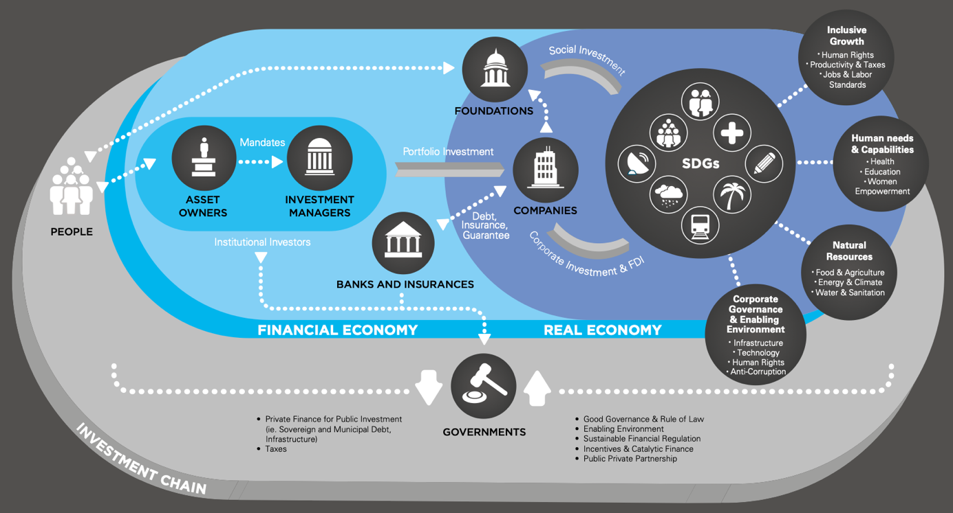

Figure XX: Actions for Private Actors to Scale Up Private Sector Involvement in Sustainable Development (Source: <https://d306pr3pise04h.cloudfront.net/docs/publications%2FPrivate_Sector_Investment_and_Sustainable_Development.pdf>)

<https://www.weforum.org/publications/>

## The role of businesses

<https://unglobalcompact.org>

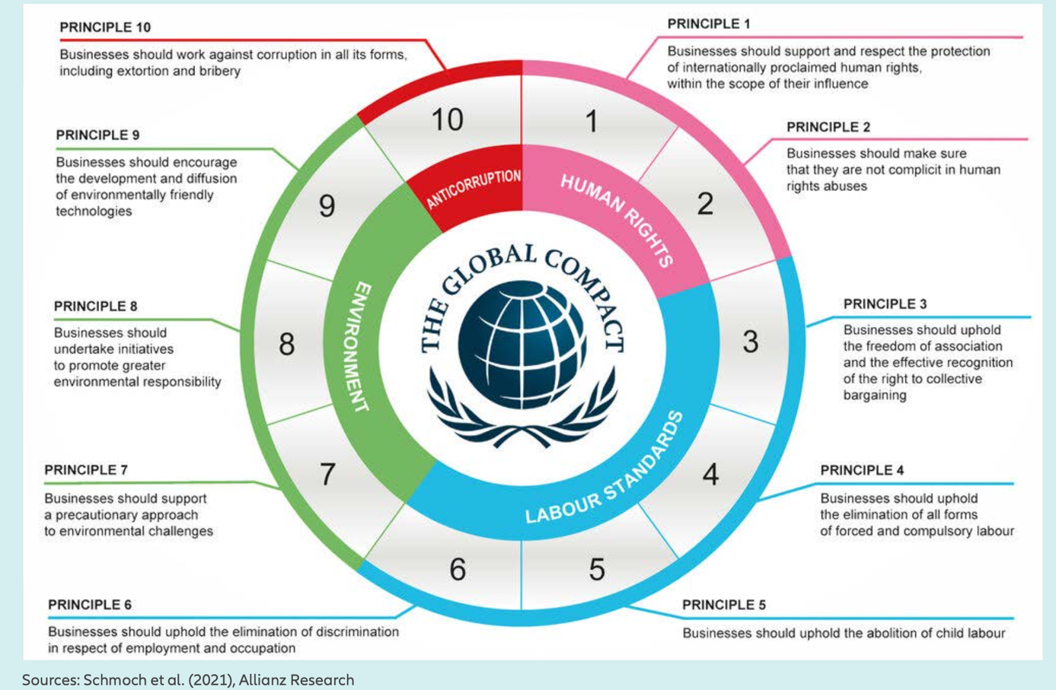

*Concurrently, the UN Global Compact is a voluntary initiative that encourages businesses to align their strategies and operations with ten universally accepted principles in the areas of human rights, labor, environment and anti-corruption measures. Initiated in 2000, the UN Global Compact aims to inspire businesses worldwide to adopt sustainable and socially responsible policies and to engage in reporting their progress. The Compact is founded on ten principles (Figure 3) that are derived from various United Nations conventions. The initiative encourages companies to align their operations and strategies with these principles, promoting an ethos of universal responsibility (Kell, 2017).*

* <https://www.allianz.com/content/dam/onemarketing/azcom/Allianz_com/economic-research/publications/specials/en/2025/january/2025-01-21-Insurance_SDG-AZ.pdf>
* <https://www.unepfi.org/insurance/insurance/>

## Corporate governance, reporting and the UN SDGs

ISO standard

In September 2024, the International Standards Organisation (ISO) published a new standard in line with the UN SDGs - ISO/UNDP PAS 53002. The overall aim is to provide organisations with “a unified approach to systematically manage and optimise their impact on sustainable development across various operational aspects.” The standard is applicable to both public and private sector organisations. It aims to complement existing ISO standards such as ISO 14001 which focusses on environmental management systems and ISO 22000 which addresses food safety management, and aims to look at how an organisation’s operations and strategy aligns with the UN SDGs as a whole.

The guidelines aim “to help shift an organisation from SDG alignment to placing SDGs at the core of business operations.” For more details, please see <https://www.iso.org/standard/87945.html> and <https://www.youtube.com/watch?v=9czfe1oFKeA>

To see how the UN SDGs align with existing ISO standards (prior to ISO/UNDP PAS 53002), please see <https://www.iso.org/sdg>.

Expanding the role of Chief Sustainability Officer

Given the recent rise of global climate change disclosure requirements e.g. TCFD and related disclosures, companies are adjusting their governance structure internally for example with explicit Chief Sustainability Officer (CSO) roles. There is a broader question of if the CSO role should also incorporate UN SDG within their remit for a company, given the increased focus on ESG and that ESG and UN SDG goals can be mapped across to each other (see Figure 5).

Expanding disclosure requirements for companies

We are seeing a large drive from voluntary to mandatory reporting mainly focussed on climate change disclosure requirements for example via TCFD and the more recent ISSB’s IFRS S1 (and S2 (climate change). Recent EU CSRD requirements has expanded this to include social and governance as well which forms part of wider ESG requirements, though we expect multi-national companies to incorporate and other geographies to expand their remit to broaden to wider ESG reporting.

Beyond disclosure requirements, companies should consider sustainability across their whole supply chain, for example when requesting or responding to RFPs and business transactions. Beyond existing ethical and compliance background checks, businesses should consider further consider and request sustainability goals, initiatives and alignments of companies across their supply chain. This will indirectly promote sustainability.

## The role of the insurance industry and the UN SDGs

* <https://a2ii.org/en/sustainable-development-goals>
* <https://www.unepfi.org/insurance/insurance/>

A report published in January 2025 by Allianz explores the role of the insurance industry and the UN SDGs. Beyond the impact of recent wars and the COVID-19 pandemic, it explains that progress is also lacking due to the accelerating climate crisis. Though only directly mentioned in one SDG (SDG target 8.10 on financial access), the report argues that the insurance industry can play a pivotal role in combatting the climate crisis and hence influence 30% of SDG targets. Also the report suggests, “by integrating resilience-building measures, such as nature-based solutions, into their product offerings, the insurance industry can help the insured (across sectors) adapt to climate risks, thereby safeguarding and advancing SDG progress via these sectors and unlocking SDG target co-benefits of resilience-building measures.” (Source: <https://www.allianz.com/en/economic_research/insights/publications/specials_fmo/250121-sustainable-development-goals.html>)

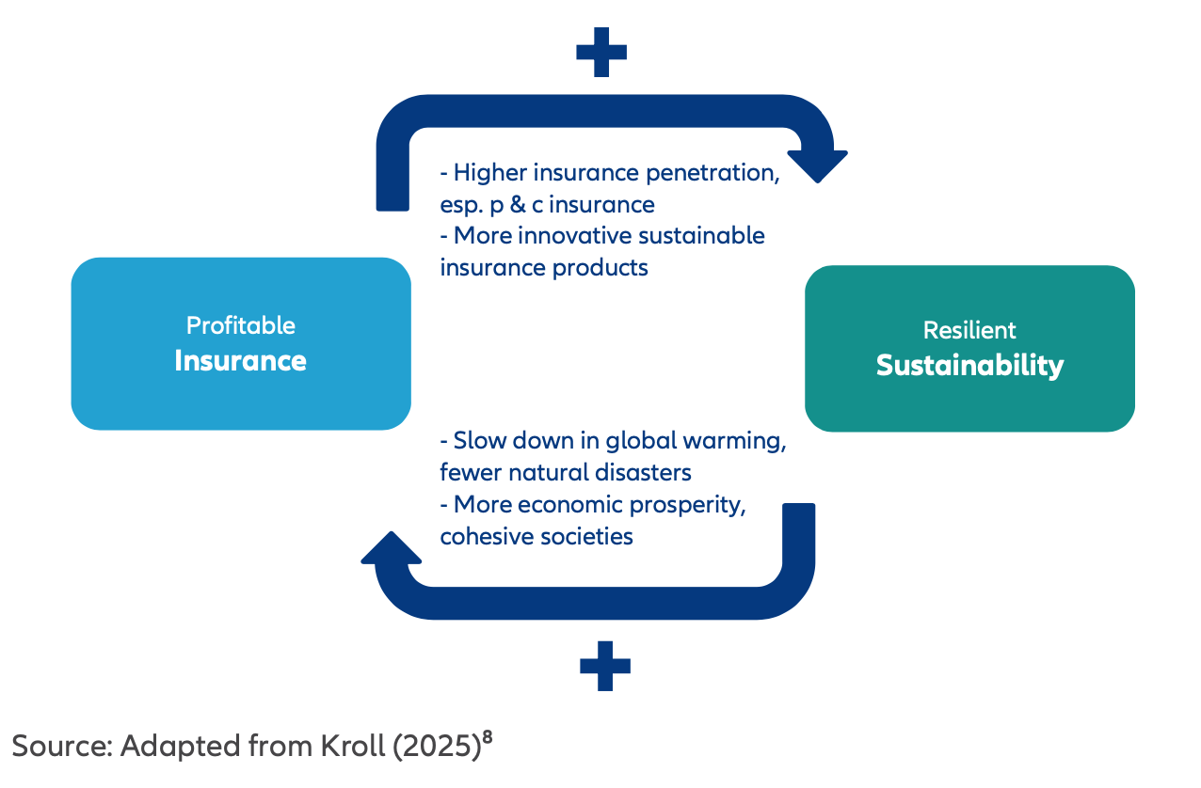

Figure XX: (Source: <https://www.allianz.com/en/economic_research/insights/publications/specials_fmo/250121-sustainable-development-goals.html>)

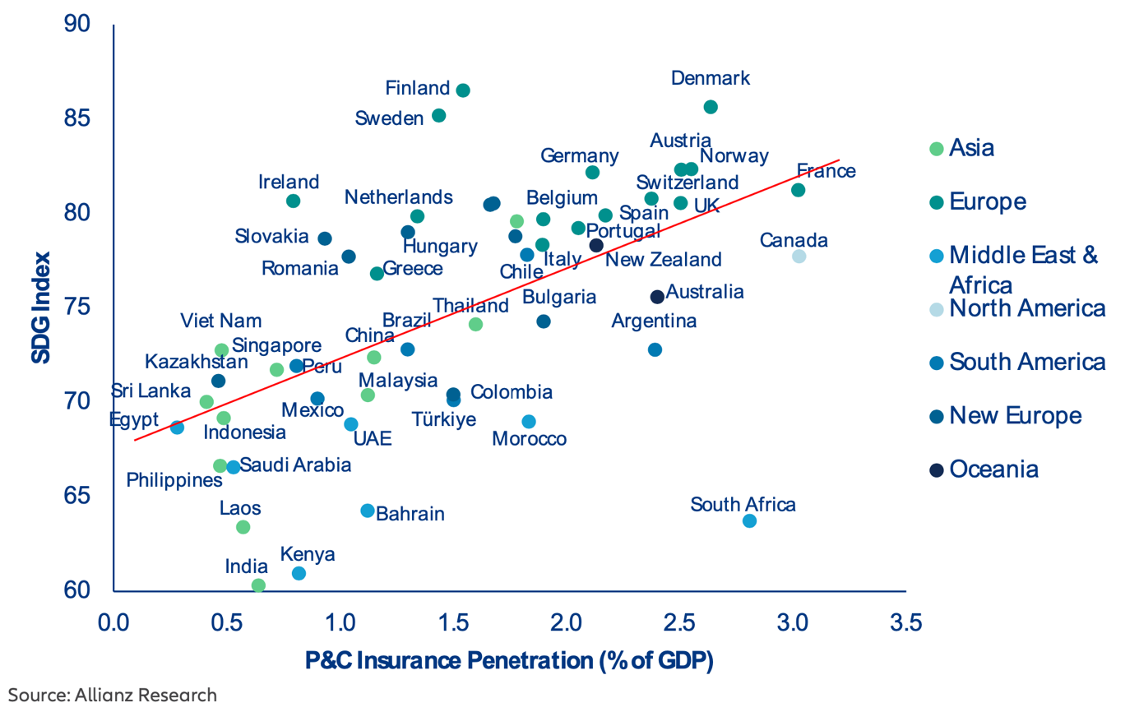

Figure XX: Correlation between P&C insurance penetrations (as a percentage of GDP) and the GDP across a range of countries. (Source: <https://www.allianz.com/en/economic_research/insights/publications/specials_fmo/250121-sustainable-development-goals.html>)

* <https://documents1.worldbank.org/curated/en/560821632197166715/pdf/The-Insurance-Sector-s-Contribution-to-the-Sustainable-Development-Goals-SDGs.pdf>
* <https://www.dublinuniversitypress.com/_files/ugd/ace0db_fb00d80903284b62a7b9210274eeaf1d.pdf>

## Inner Development Goals

Officially founded in 2020 by a range of stakeholders, the Inner Development Goals is a non-profit organisation set up and provides a framework for individuals, groups and organisations to align behaviours such that their behaviours align with actions which map across to the UN SDGs. (Sources: <https://www.motivation.se/partner/inner-development-goals/>, <https://innerdevelopmentgoals.org>)

The framework covers 23 skills across 5 dimensions: being, thinking, relating, collaborating and acting. Companies including Google, Ikea and Volvo have integrated this framework into their organisational strategies. (Source: <https://innerdevelopmentgoals.org/partnerships/>

For more details, please see <https://innerdevelopmentgoals.org>.

# Looking ahead

## Future direction of travel

Addressing progress for the UN SDGs by 2030, or in fact by any future date, is complex and as an oversimplification can be described as a challenge. Many if the issues underlying issues such as inequalities are potentially within society and have historical roots – explored more in our country-specific blogs which can be found here <https://blog.actuaries.org.uk/authors/ifoa-s-data-science-sustainability-and-climate-change-working-party/>.

There is a broader question if ever such inequalities can be eradicated under any circumstances.

## Recommendations

Potential suggested proposals for progress include:

1. A rethink of the priorities and the deadline. It is highly unlikely that the overall deadline of 2030 will be met. We need to consider a new target deadline, but not solely of the aim of “kicking the can down the road”. If we are collectively and as a global community serious on addressing these issues, we need to consider open dialogue with the aim of producing structured transition plans for example to assist countries facing more challenges, to help them prioritise and address challenges they face in a respectful (e.g. of local challenges and existing global financial debt) but meaningful and realistic manner i.e. multilateralism should be core to any future progress. [COUNTER e.g. popularism, nationalism, protectionism] Further we should consider what support is required by the international community to help them along this transition, working in partnership.
2. A move from voluntary to some form of mandatory enforcement of UN SDG progress, with the underlying aim of encouraging a positive outcome. Ensure all UN Member States produce a progress report, Voluntary National Reviews (VNRs), which is published each year.
3. Following on from the local governments should ensure that there is meaningful action to address, and clear policy drive incorporating changes.
4. Comparable emergency fund set up similar to the recent Loss and Damage Fund which was introduced to tackle climate change, but for all UN SDGs.
5. Climate change takes up much of social media and reporting media coverage. Is this potentially disproportionate and unfair on the remaining UN SDGs? Should we have a more balanced / equal focus on the other UN SDGs?
   1. For example, currently there is a tri-COP discussed earlier of climate change, biodiversity and desertification. Do we need to consider additional COPs for each other UN SDG without oversaturation?
   2. Further, can we take advantage of the idea of “nexus” introduced earlier in Section 2, acknowledging the fact that many of the UN SDGs are interconnected and if we address one of the UN SDGs there will be a ripple effect on other related UN SDGs i.e. do we broaden the conversation of the existing COPs such that it discusses other UN SDGs.
   3. Do we need to change the current format of the UN Summits from every four years to every one year?
6. Wider education and awareness drive by governments and NGOs, without saturating people’s appetite.
7. Wider partnership with private sector – both investment (to make up
   1. E.g. incorporate UN SDG targets into CEO remuneration?
   2. Wider encourage of ESG (i.e. SDG) disclosure requirements as per CSRD.
8. Wider acceptance and action by (developed) countries of “negative spillovers” they cause.
   1. Similar to Scope 1, 2 and 3 reporting for climate change disclosures, countries need to factor in wider negative spillover impacts and look to take positive actions to reduce / remove this, whilst ensuring that the local workforce in the periphery is not negatively impacted e.g. via job loss.
   2. Adjustment to GDP or metrics to allow for spillovers.
   3. <https://sdg-action.org/how-to-curb-negative-international-spillovers/>
9. An improvement in data collection and quantitative analysis for some of the UN SDGs e.g. XX, to help better understand and quantify progress. In doing so, countries and agencies can focus resources effectively to addressing UN SDG problems and tracking solutions. Potentially, is this overfocussing on discussion / analysis versus action?
10. Do we need to adjust GDP to incorporate e.g. biodiversity and social benefit? Do private companies need to adjust their definition of profitability to make similar adjustments?
11. Do we want better alignment of goals and collaboration between governments, companies and individuals, as well as between countries e.g. the Global North and Global South?
12. Encourage a move from governmental and structural to behavioural.
13. <https://www.weforum.org/stories/2024/09/un-summit-future-sdgs/>
14. <https://commission.europa.eu/strategy-and-policy/sustainable-development-goals/eu-and-united-nations-common-goals-sustainable-future_en>
15. <https://sdgs.un.org/sites/default/files/2020-07/24797GSDR_report_2019.pdf>
16. <https://sdgs.un.org/publications/future-now-science-achieving-sustainable-development-gsdr-2019-24576>
17. <https://www.cepal.org/en/notes/hlpf-2024-summit-future-will-countries-what-it-takes-meet-sustainable-development-goals-sdgs>
18. <https://www.un.org/sustainabledevelopment/development-agenda/>
19. [https://unstats.un.org/sdgs/report/2024/?_gl=1*558vff*_ga*Mjk5NDQ1NzQ1LjE3MzQ4OTU3NjE.*_ga_TK9BQL5X7Z*MTczNDk5NzM4Ny4yLjAuMTczNDk5NzM4OC4wLjAuMA](https://unstats.un.org/sdgs/report/2024/?_gl=1*558vff*_ga*Mjk5NDQ1NzQ1LjE3MzQ4OTU3NjE.*_ga_TK9BQL5X7Z*MTczNDk5NzM4Ny4yLjAuMTczNDk5NzM4OC4wLjAuMA)..
20. <https://unstats.un.org/sdgs/report/2023/breaking-through/>
21. <https://en.wikipedia.org/wiki/Immanuel_Wallerstein>
22. <https://www.un.org/en/summit-of-the-future/pact-for-the-future>

# References

1. Chenary, K., Pirian Kalat, O. & Sharifi, A., 2023. *Forecasting sustainable development goals scores by 2030 using machine learning models.* [Online]   
   Available at: https://doi.org/10.1002/sd.3037  
   [Accessed 20 October 2024].
2. Kharas, H., McArthur, J. W. & Onyechi, O., 2024. *How is the world doing on the SDGs? Four tests and eight findings.* [Online]   
   Available at: https://www.brookings.edu/articles/how-is-the-world-doing-on-the-sdgs-four-tests-and-eight-findings/  
   [Accessed 23 September 2024].
3. UN, 2015. *United Nations Summit on Sustainable Development, 25-27 September 2015, New York.* [Online]   
   Available at: https://www.un.org/en/conferences/environment/newyork2015  
   [Accessed 22 September 2024].
4. UN, no date (a). *Sustainability.* [Online]   
   Available at: https://www.un.org/en/academic-impact/sustainability  
   [Accessed 22 September 2024].
5. UN, no date (b). *Agenda 21.* [Online]   
   Available at: https://sdgs.un.org/publications/agenda21  
   [Accessed 22 September 2024].
6. UN, no date (c). *Voluntary National Reviews.* [Online]   
   Available at: https://sustainabledevelopment.un.org/vnrs/  
   [Accessed 22 September 2024].

1. Acknowledgements

Please see below acknowledgements for the review of the code and paper:

* Code review by Cem Öztürk [[Link](http://linkedin.com/in/ozturkcemm)].
* Technical review of paper by:
  + Dr Alexey Mashechkin [[Link](https://www.linkedin.com/in/alexey-mashechkin/)].
  + Assoc. Prof. George Tzougas [[Link](https://www.linkedin.com/in/george-tzougas-648711294/)].
* Review of graphs and tables within the paper by Shubham Mehta [[Link](http://linkedin.com/in/mehta-shubham)].

1. Useful links

Below is a list of links which we hope that the reader finds useful.

|  |  |
| --- | --- |
| Name | Link |
| AI2ii | <https://a2ii.org/en/home> |
| AI SDG annual summit | <https://aiforgood.itu.int> |
| AI SDG projects | <https://www.ai-for-sdgs.academy> |
| Google AI Social Impact | <https://ai.google/advancing-ai/social-impact/> |
| International Atomic Energy Agency | <https://www.iaea.org/about/overview/sustainable-development-goals> |
| Our Future Agenda | <https://ourfutureagenda.org> |
| SDG Action | <https://sdg-action.org> |
| UN Department of Economic and Social Affairs | <https://www.un.org/en/desa> |
| UN DP AI for development | <https://www.undp.org/digital/ai> |
| UN SDGs | <https://sdgs.un.org> |
| UN SDG statistics | <https://unstats.un.org/sdgs> |
| UN SDSN | <https://www.unsdsn.org> |
| WEF Centre for the Fourth Industrial Revolution | <https://centres.weforum.org/centre-for-the-fourth-industrial-revolution/home> |

1. Alternative index measures

Below is a table listing a subset of alternative measures to the UN SDG index. Please note that the below is not meant to be a comprehensive audit of such indices or scores.

(Source: <https://hdr.undp.org/system/files/documents/klasenfinal.pdf>)

|  |  |
| --- | --- |
| Index name | Brief description |
| 1. Human Development Index (HDI) | * First described in 1990, the Human Development Index focussed on people and their opportunities rather than economic growth alone. (Source: <https://sdg-action.org/the-human-development-index-a-better-indicFator-for-success/>) * The HDI framework is scored based on three underlying metric areas: education, income and life expectancy. * There are limitations of this index however as it does not directly account for environmental / climate impacts unlike the SDG index earlier. |
| 1. Inequality-adjusted Human Development Index (IHDI) | * Adjusts the HDI for inequality in the distribution of each dimension. |
| 1. Multidimensional Poverty Index (MPI) | * Measures the multiple deprivations that people face in health, education, and living standards. |
| 1. Environmental Performance Index (EPI) | * Ranks countries on 24 performance indicators across ten issue categories covering environmental health and ecosystem vitality. |
| 1. Ecological Footprint | * Measures the demand on Earth's resources by comparing human consumption with the planet's ecological capacity to regenerate. |
| 1. Global Peace Index (GPI) | * Assesses the relative peacefulness of nations and regions. |
| 1. Global Competitiveness Index (GCI) | * Evaluates the competitiveness landscape of economies, providing insight into the drivers of productivity and prosperity. |
| 1. Social Progress Index (SPI) | * Measures the extent to which countries provide for the social and environmental needs of their citizens. |
| 1. Climate Change Performance Index (CCPI) | * Ranks countries based on their climate protection performance. |
| 1. Biodiversity Intactness Index (BII) | * Measures the impact of human activities on biodiversity. |
| 1. Global Commons Stewardship Index | * <https://gcsi.unsdsn.org> |

* Compare maps of indices…?
* <https://www.oecdbetterlifeindex.org>

1. Alternative charts of global UN SDG progress

## Individual progress updates of SDGs and alternative indices

* UN SDG index methodology [https://dashboards.sdgindex.org/chapters/methodology#](https://dashboards.sdgindex.org/chapters/methodology)

In this appendix, we present a range of alternative indices to measure progress across some individual SDGs across the globe.

SDG 1 – No poverty

The national poverty headcount ratio is the percentage of the population living below the national poverty line.

Figure XX: Share of population living in extreme poverty (2023) - extreme poverty is defined as living below the International Poverty Line of USD 2.15 per day. This data is adjusted for inflation and for differences in the cost of living between countries.

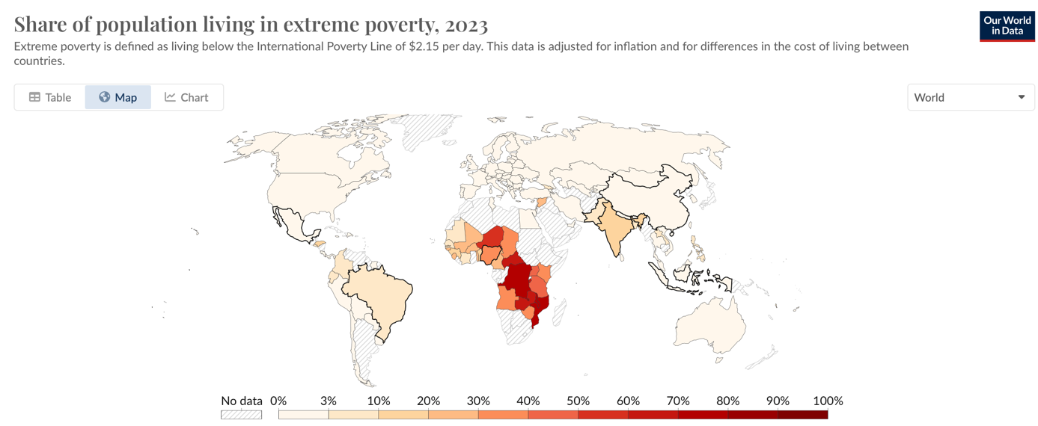

(Source: <https://ourworldindata.org/grapher/share-of-population-in-extreme-poverty>)

SDG 2 – Zero hunger

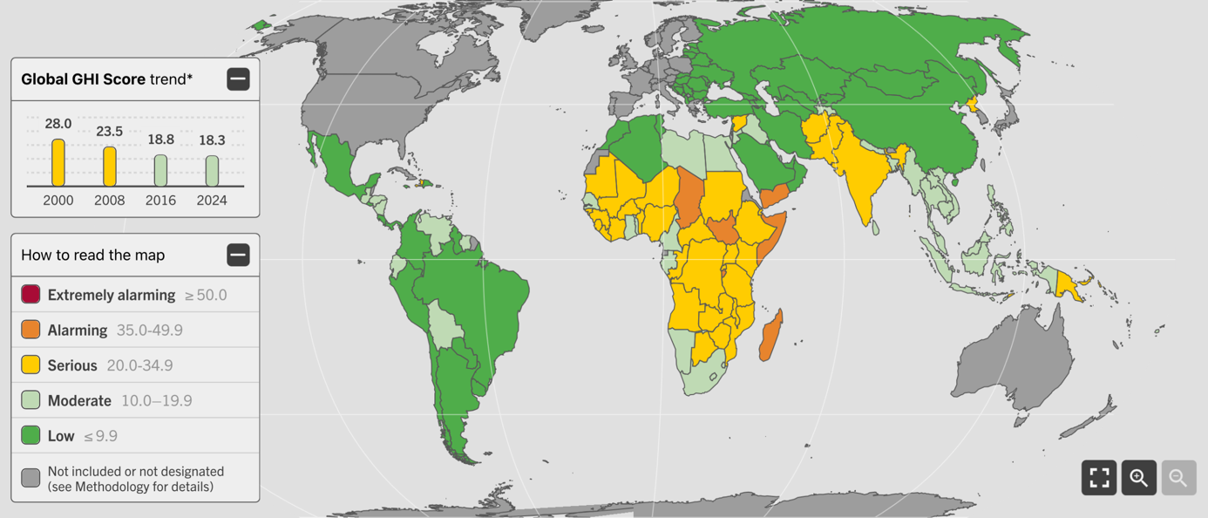

<https://www.globalhungerindex.org>

SDG 4 – Quality education

<https://worldpopulationreview.com/country-rankings/education-index-by-country>

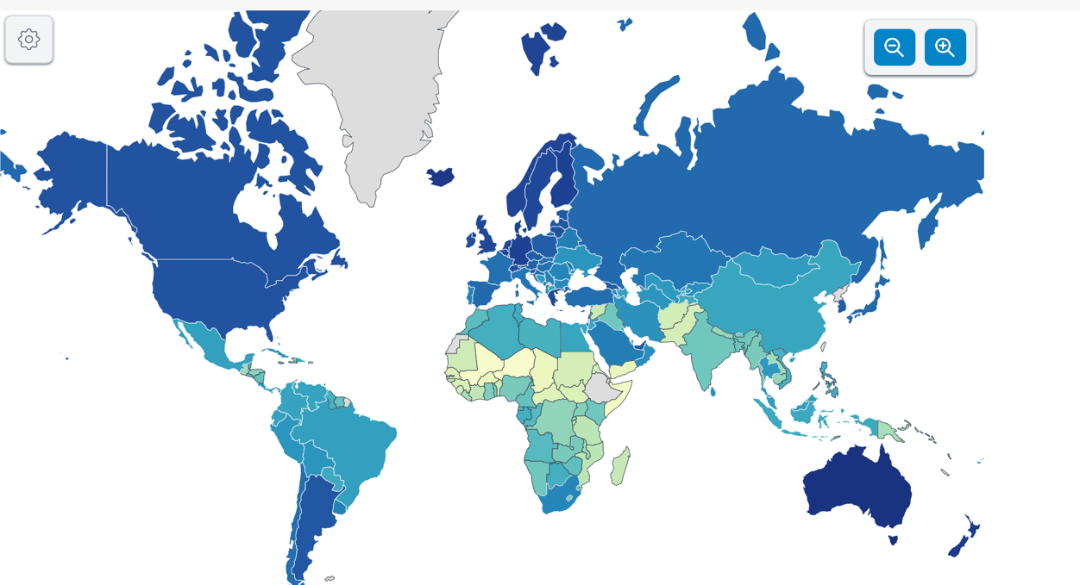

SDG 10 – Reduced inequalities

Alternative measures for wage inequality within a society include the Gini coefficient. Gini coefficient is a measure of income inequality within a society. It is a score between nil and 1, where nil means perfect equality and 1 reflects maximum inequality

Figure XX: Global map of Gini coefficient for each country in 2024, with scale going from nil to 100. The percentage % sign has been dropped for simplicity.

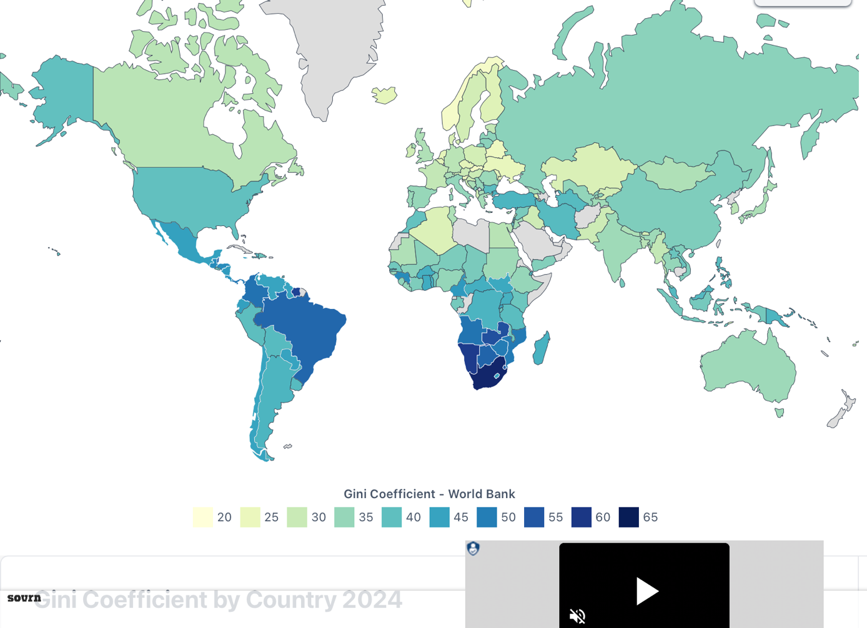

(Source: <https://worldpopulationreview.com/country-rankings/gini-coefficient-by-country>)

SDG 13 – Climate action

Figure XX : The Climate Change Performance Index (CCPI) is an instrument to enable transparency in national and international climate politics. The CCPI uses a standardized framework to compare the climate performance of 63 countries and the EU, which together account for over 90% of global greenhouse gas emissions. The climate mitigation performance is assessed in four categories: GHG Emissions, Renewable Energy, Energy Use and Climate Policy. (Source : <https://ccpi.org>)

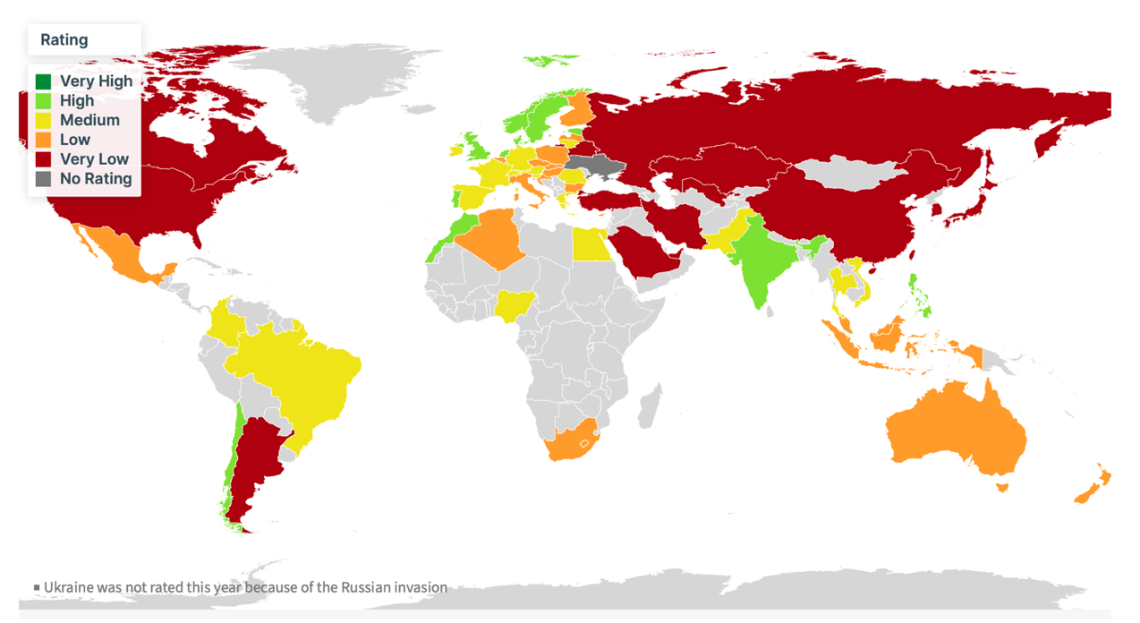

Section 2: Human Development Index

An alternative method is the Human Development Index. This represents XX.

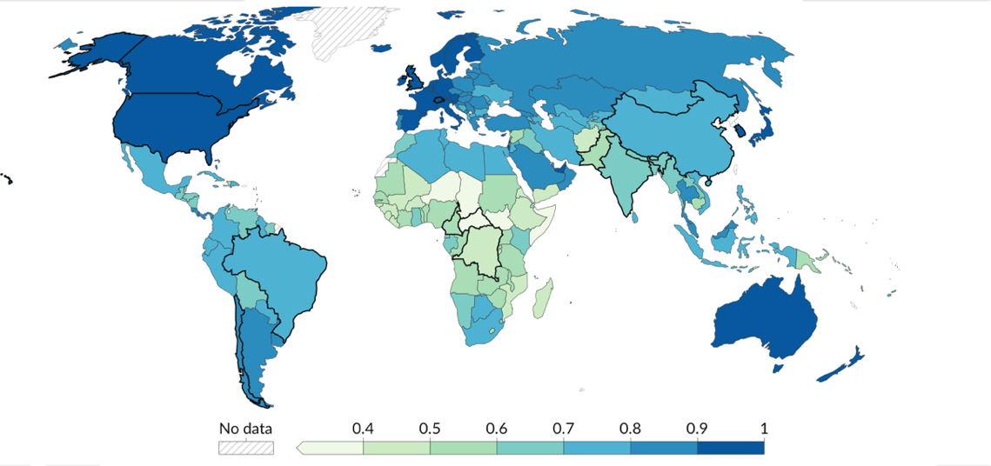

Figure 6: The Human Development Index (HDI) is a summary measure of key dimensions of human development: a long and healthy life, a good education, and a decent standard of living. Higher values indicate higher human development. (Source: <https://ourworldindata.org/human-development-index>)

Section 3: AI adoption readiness index

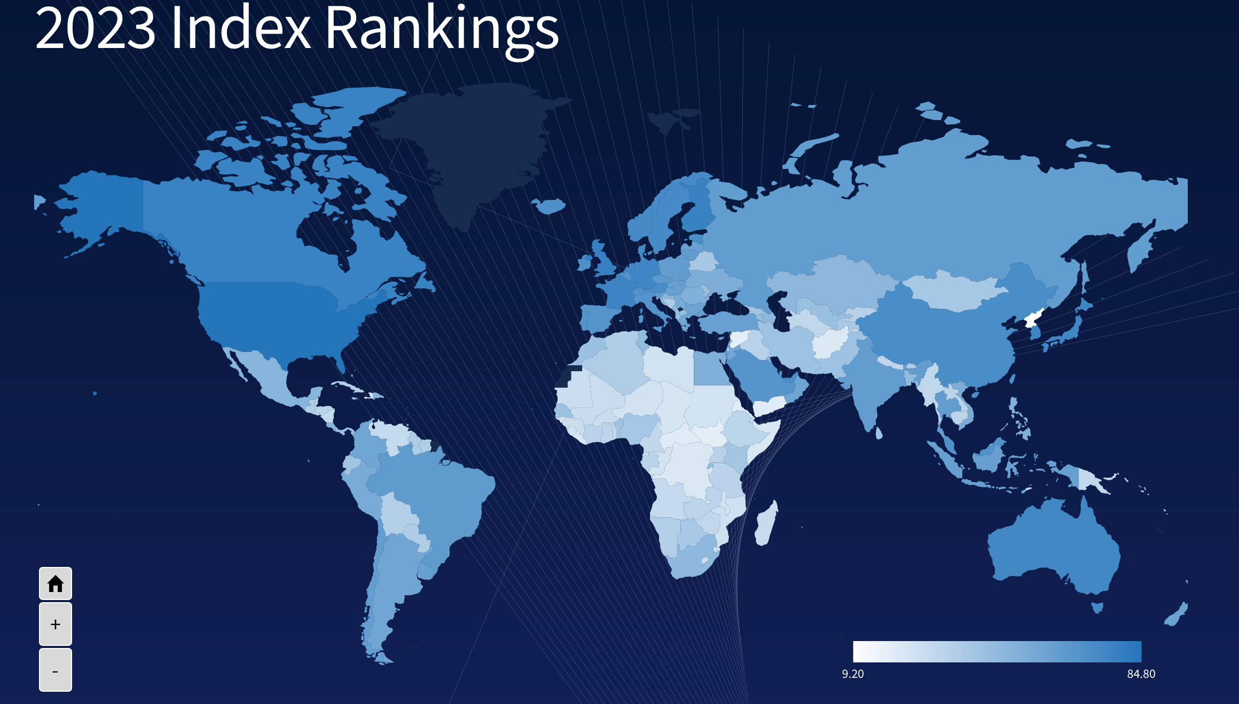

Figure 10a: 2023 Index Rankings (Source: <https://oxfordinsights.com/ai-readiness/ai-readiness-index/> )

* <https://en.wikipedia.org/wiki/Gender_Inequality_Index>
* <https://en.wikipedia.org/wiki/Corruption_Perceptions_Index>
* <https://en.wikipedia.org/wiki/OECD_Better_Life_Index>
* <https://en.wikipedia.org/wiki/World_Happiness_Report>
* <https://en.wikipedia.org/wiki/International_development>
* <https://www.bbc.co.uk/bitesize/guides/z2mfpbk/revision/3>
* <https://hdr.undp.org/data-center/human-development-index#/indicies/HDI>
  + GDP per capita is a better inidicator vs GDP
  + <https://en.wikipedia.org/wiki/Human_Development_Index>
* Inherently many of the indices are correlated to GDP; GDP is not necessarily

<https://www.investopedia.com/ask/answers/043015/what-difference-between-international-monetary-fund-and-world-bank.asp>

<https://unfccc.int/topics/introduction-to-climate-finance>

<https://datatopics.worldbank.org/sdgatlas/?lang=en>

<https://www.worldbank.org/ext/en/home>

<https://www.worldbank.org/en/programs/sdgs-2030-agenda>

<https://unacov.uk/un-system-chart-2023/>

<https://ourworldindata.org/grapher/human-rights-index-vdem>

1. United Nations Framework

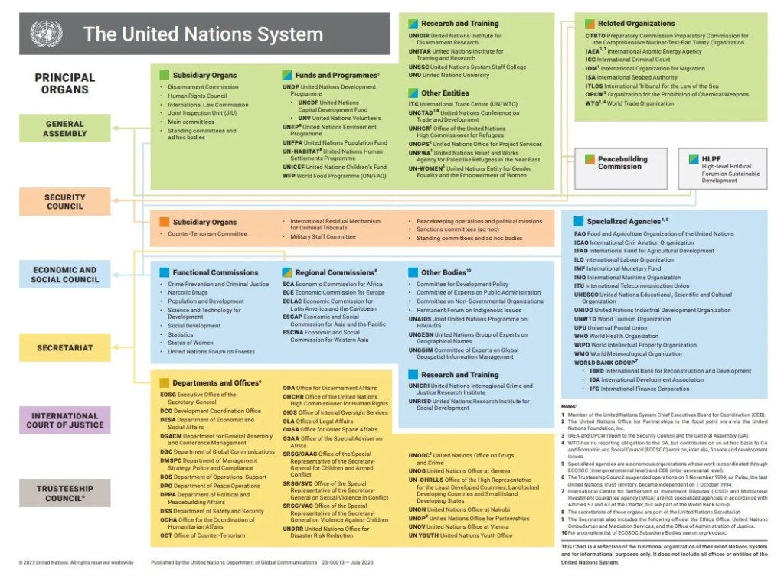

<https://www.worldbank.org/en/programs/sdgs-2030-agenda>

<https://www.worldbank.org/ext/en/home>

<https://www.worldbank.org/en/news/immersive-story/2024/12/17/2024-in-nine-charts?intcid=ecr_hp_headerA_en_ext>

<https://en.wikipedia.org/wiki/United_Nations>

<https://www.un.org/en/about-us/main-bodies>

<https://www.un.org/en/ga/about/background.shtml>